Coursework Submission Cover Sheet
Student ID (LMU ID) | 24077283
Module Code and Name | CS7P01NM - MSc Project
Assessment No/Title | Draft 4
Assessment Submission Deadline | 24th of October 2026, 11:59 PM
Module Leader | Dr. Kaneeka Vidanage
Academic Integrity and Plagiarism
You are reminded that there exist regulations concerning plagiarism. Extracts from these regulations are printed below. Please sign below to say that you have read and understand these extracts:
This header sheet should be attached to the work you submit. No work will be accepted without it.
Extracts from University Regulations on
Cheating, Plagiarism and Collusion
Section 2.3: "The following broad types of offence can be identified and are provided as indicative examples ….
- Cheating: including taking unauthorized material into an examination; consulting unauthorized material outside the examination hall during the examination; obtaining an unseen examination paper in advance of the examination; copying from another examinee; using an unauthorized calculator during the examination or storing unauthorized material in the memory of a programmable calculator which is taken into the examination; copying coursework.
- Falsifying data in experimental results.
- Personation, where a substitute takes an examination or test on behalf of the candidate. Both candidate and substitute may be guilty of an offence under these Regulations.
- Bribery or attempted bribery of a person thought to have some influence on the candidate's assessment.
- Collusion to present joint work as the work solely of one individual.
- Plagiarism, where the work or ideas of another are presented as the candidate's own.
- Other conduct calculated to secure an advantage on assessment.
- Assisting in any of the above.
Some notes on what this means for students:
- Copying another student's work is an offence, whether from a copy on paper or from a computer file, and in whatever form the intellectual property being copied takes, including text, mathematical notation and computer programs.
- Text Box Taking extracts from published sources without attribution is an offence. To quote ideas, sometimes using extracts, is generally to be encouraged. Quoting ideas is achieved by stating an author's argument and attributing it, perhaps by quoting, immediately in the text, his or her name and year of publication, e.g. " e = mc2 (Einstein 1905)". A references section at the end of your work should then list all such references in alphabetical order of authors' surnames. (There are variations on this referencing system which your tutors may prefer you to use.) If you wish to quote a paragraph or so from published work then indent the quotation on both left and right margins, using an italic font where practicable, and introduce the quotation with an attribution.
Please sign below to say that you have read and understand these extracts:
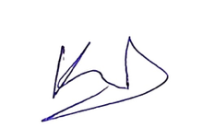

----------------------------- | 10/24/2026
Student Signature | Date

A Multi-Signal Framework for Detecting Knowledge Decay in Enterprise Knowledge Bases Using Authoritative Source Comparison

Table of Contents
Chapter 1 .Introduction 8
1.1. Chapter Overview 8
1.2. Problem Background 8
1.3. Problem Statement 9
1.3.1. Background 9
1.3.2. Anchoring 10
1.3.3. General Problem 10
1.3.4. Specific Problem 11
1.4. Research Question 12
1.5. Research Motivation 12
1.6. Research Aim 12
1.7. Research Objectives 12
1.8. Rich Picture of the Proposed Solution 13
1.9. Resource Requirements 14
1.10. Project Scope 16
1.11. Chapter Summary 17
Chapter 2 . Literature Review 18
2.1. Chapter Overview 18
2.2. Conceptual Taxonomy of Literature Organisation 18
2.3. Domain Overview 19
2.4. Existing Systems, Frameworks and Designs 21
2.5. Technological Analysis 23
2.5.1. Algorithmic Analysis 23
2.5.2. Design Analysis 24
2.5.3. Workflow Analysis 25
2.6. Reflection 26
2.7. Comparison of Existing Approaches 28
2.8. Critical Analysis and Research Gap 30
2.9. Chapter Summary 32
Chapter 3 . Methodology 33
3.1 Research Paradigm 33
3.2 Research Approach 33
3.3 Research Strategy 33
3.4 Fact Collection Mechanisms 34
3.5 Research Methodology Execution Workflow 34
3.6 Design Methodology 35
3.7 Project Management Methodology 36
3.7.1 Project Timeline 36
3.7.2 LSEP Aspect (Legal / Social / Ethical / Professional) 37
3.7.3 Risk Identification and Mitigation 38
3.8 Chapter Summary 39
Chapter 4 System Requirement Specification 40
4.1 Chapter Overview 40
4.2 Stakeholder Analysis 40
4.2.1 Implications of the Onion Model 41
4.3 Requirements Derivation Process 41
4.4 Justification of Requirement Validity 42
4.5 Use Case Diagram and Specifications 43
4.5.1 Use Case Specification: Submit Article for Analysis 44
4.5.2 Use Case Specification: Run Evaluation Batch 44
4.6 Class Diagram 45
4.7 Activity Diagram 46
4.8 Sequence Diagram 47
4.9 State and Deployment Considerations 48
4.10 Proposed System Architecture 49
4.11 Functional and Non-Functional Requirements 49
4.12 Chapter Summary 50
Chapter 5 Implementation 52
5.1. Chapter Overview 52
5.2. Steps Followed in Creating the Framework 52
5.2.1. Pseudocode and Flow Charts 54
5.2.2. Block Diagram Series 58
5.2.3. Justification of Technologies 60
5.3. Significant Implementation Attempts 63
5.3.1. Semantic Comparison Against the Authoritative Corpus 63
5.3.2 Context-Aware Terminology Drift 65
5.3.3. Handling Inconclusive Evidence 67
5.3.4. Date Extraction Chain 69
5.3.5. Score Aggregation with Weight Redistribution and Explanation 71
5.3.6. User Interface 73
5.3.7. Problems Met and How They Were Resolved 76
5.3.8. Results on Real Articles 78
5.4. Chapter Summary 79
Chapter 6 Testing & Evaluation 80
6.1. Chapter Overview 80
6.2. Test Plan and Test Cases 80
6.2.1. Non-Functional Testing 82
6.2.1.1. Accuracy 82
6.2.1.2. Performance 84
6.2.1.3. Scalability 84
6.2.2. Functional Testing 85
6.3. Testing and Evaluation Workflow 87
6.3.1. Building the Dataset 87
6.3.2. Running and Analysing 89
6.4. Review of the Test Strategies Used 90
6.4.1. Chi-Square 91
6.4.2 T-Testing 91
6.4.3. F-measure, Precision and Recall 92
6.4.4. ROC Curve 94
6.4.5. Delphi Technique 95
6.4.6. Iterative Framework 95
6.4.7. Thematic Assessment 96
6.5. Chapter Summary 97
Chapter 7 Concluding Remarks 99
7.1 Chapter Overview 99
7.2 Accomplishment of the Research Objectives 99
7.3 Problems Encountered 101
7.3.1 Problems During the Project 101
7.3.2 Limitations of the Study 101
7.4 Self-Reflection 102
7.4.1 My View of the Research 102
7.4.2 Benefits Gained and Contributions 103
7.4.3 Learning Curves 104
7.5 Business Insight of the Idea 104
7.5.1 Real-World Application Possibilities 104
7.5.2 Commercial Risks and Their Treatment 105
7.6 Future Recommendations 106

List of Figures
Figure 1.1:Rich picture of the proposed Knowledge Decay Framework 13
Figure 2.1:Concept map of literature review organization 19
Figure 4.1:Stakeholder onion model 41
Figure 4.2:Use case diagram 43
Figure 4.3:Class diagram 45
Figure 4.4:Activity diagram - article analysis workflow 46
Figure 4.5:Sequence diagram - Submit Article for Analysis 47
Figure 4.6:Sequence diagram - Run Evaluation Batch 48
Figure 4.7:Proposed system architecture 49
Figure 5.1:Flow chart of the semantic similarity signal 54
Figure 5.2:Flow chart of the terminology drift signal 55
Figure 5.3:Flow chart of the broken links signal 55
Figure 5.4:Flow chart of the date extraction chain used by the temporal metadata signal 56
Figure 5.5:Block diagram of the Multi-Signal Knowledge Decay Framework 58
Figure 5.6:Block diagram of the corpus preparation steps 59
Figure 5.7:Terminal output confirming 4,984 markdown files in the cloned corpus 64
Figure 5.8:Early test run in which a 202 response was wrongly reported as a broken link 69
Figure 5.9:Weight redistribution when a signal is excluded (a) and the contribution of each signal to the InventiveHQ score (b) 72
Figure 5.10:The interface after a URL has been submitted 74
Figure 5.11:Score and gauge for the same article (40.4 out of 100) 74
Figure 5.12:Lower signal panels and explanation for the InventiveHQ article 75
Figure 5.13:A low-decay result (5.3 out of 100) for a maintained Entra ID page 76
Figure 5.14:Early failure on a GeeksforGeeks page caused by certificate checking on the virtual machine 77
Figure 5.15:Knowledge Decay Scores for the four real articles, with the provisional bands at 30 and 60 79
Figure 6.1:Confusion matrix at the threshold of 30 83
Figure 6.2:Workflow of the testing and evaluation 87
Figure 6.3:Scores of the 44 articles by true label 92
Figure 6.4:Precision, recall and F1 at different thresholds 92
Figure 6.5:F1 and AUC when a signal is left out or used alone 93
Figure 6.6:ROC curve of the combined score 95

List of Tables

Table 1.1:Resource requirements 15
Table 1.2:Project scope 16
Table 2.1:Reflection - synthesis of individually reviewed literature and its impact on this research 26
Table 2.2:Comparison of existing retrieval and decay-detection approaches 29
Table 3.1:Research methodology execution workflow 35
Table 3.2:Project timeline 37
Table 3.3:LSEP analysis in relation to this research 37
Table 3.4:Risk identification and mitigation strategy 38
Table 4.1:Mapping of requirement areas to research objectives and literature findings 42
Table 4.2:Use case specification - Submit Article for Analysis 44
Table 4.3:Use case specification - Run Evaluation Batch 44
Table 4.4:Functional requirements 49
Table 4.5:Non-functional requirements 50
Table 5.1:Build stages and the evidence used to accept each stage 53
Table 5.2:Summary of the five decay signals 57
Table 5.3:Traceability of requirements to code modules 59
Table 5.4:Programming language 61
Table 5.5:Libraries used and the reason for each 61
Table 5.6:Back-end and front-end choices 63
Table 5.7:Proof of concept for the similarity search 65
Table 5.8: Equivalence check between the NumPy and FAISS versions 65
Table 5.9:Date extraction on real pages 71
Table 5.10:Provisional parameters of the prototype 73
Table 5.11:Messages shown when the pipeline cannot return a score 76
Table 5.12:Main problems found during development 77
Table 5.13:Knowledge Decay Scores for four real articles 78
Table 6.1:The ten main test cases (Req. = requirement) 80
Table 6.2:Accuracy measures at the threshold of 30 with 95% intervals 83
Table 6.3:Time per article in the batch run 84
Table 6.4:Measured and calculated scale figures 85
Table 6.5:Composition of the labelled dataset 88
Table 6.6:The seven strategies and their fit to this research 90
Table 6.7:Effect of the terminology exemption on the two articles that would change answer 94
Table 6.8:The eight wrong answers and their likely causes 96
Table 7.1:Evidence for each research objective 99
Table 7.2:Triangulation of the accuracy result 100
Table 7.3:Limitations of the study and their effect on the conclusions 102
Table 7.4:Main commercial risks and how they could be reduced 105

List of Listings

Listing 5.1:Pseudocode of the deprecated technology signal 57
Listing 5.2:Pseudocode of the score aggregation 57
Listing 5.3:Extract from semantic_similarity.py: matching each article paragraph to its closest corpus chunk 64
Listing 5.4:Extract from terminology_drift.py: the two exemption patterns 66
Listing 5.5:Extract from terminology_drift.py: counting a match or exempting it 66
Listing 5.6:Extract from broken_links.py: classifying one link 67
Listing 5.7:Extract from extract_date.py: the three-step fallback chain 70
Listing 6.1:The link outcome cases used in the link checker test (link_status_test.py) 86
Listing 6.2:Counting the outcomes and calculating the measures (batch_eval.py) 89
Listing 6.3:Recomputing a score with one signal left out or used alone (batch_eval.py) 89

Introduction

Chapter Overview
This chapter outlines the Research Problem being addressed by this Study. It commences with an outline of the background & context for Knowledge Decay in Enterprise Technical Documentation prior to narrowing to a Formally Structured Problem Statement. The chapter will also include the Research Question, Motivation and the Aims and Objectives that underpin this Study.

Problem Background
Enterprise organizations are increasingly relying on both official vendor documentation and third-party technical content in order to perform daily IT operations. This trend has been observed in developer communities more broadly, where practitioners routinely consult community-authored content alongside official sources (Zhang et al., 2021). With the rate at which cloud technology is changing, along with evolving security processes, and terminology used by vendors; the collective body of knowledge regarding IT is also subject to rapid obsolescence. This is a problem this research study calls "knowledge decay" (Tu et al., 2024). If left unchecked, it is possible that IT professionals will apply outdated configuration options, follow defunct procedures and/or utilize terminology that does not reflect the vendor's current nomenclature for products, which aligns with the findings made by Zhang et al. (2021) who found that nearly all obsolete community authored content was neither corrected nor removed from the site.
A concrete example illustrates how this occurs in real world applications. In 2022, an independent third-party created a tutorial about creating conditional access polices for "Azure Active Directory", as part of the tutorial's product name. In 2023, Microsoft branded "Azure Active Directory" as "Microsoft Entra ID." As such, Microsoft also retired some legacy configuration blades that were originally mentioned by name within the first blog post. As an IT professional who found and followed the original (unmodified) blog post in 2026 will have applied guidance which was written against product identities, navigation paths and sets of controls that have either been significantly altered or eliminated from existence since they last existed in their original format; and there would likely be little or no visual evidence that the circumstances had changed.
This is one example of a recurring patterns throughout enterprise technology documentation. The examples illustrated here represent typical, rather than unique, occurrences of product branding changes, feature deprecations, and terminology change are common experiences in cloud-based platforms -- they occur frequently enough so they should be considered normal.
The scale of the underlying problem is further supported by industry reports: organizations that employ inadequate approaches to managing their knowledge are subject to considerable wasted time and resources as well as redundant effort and unnecessary rework (ProcedureFlow, 2026; Bloomfire, 2026; Zoho, 2023). In this manner the costs of these inefficiencies result directly from outdated information being unidentifiable when accessed, rather than simply due to an organization's complete absence of documentation.

Problem Statement

Background
The increasing adoption of cloud computing, Artificial Intelligence (AI) and digital transformation is making it harder for organisations to keep their technical knowledge up to date. Continuous software releases, evolving security practices and shifting best practices cause technical documentation to lose relevance faster than before, a problem referred to as "Knowledge Decay" (Tu et al., 2024). IT professionals rely on both official vendor documentation and third-party resources; while vendor documentation is authoritative, third-party articles are rarely revised after publication and may continue to reference obsolete technologies or deprecated methods.
The fact that IT personnel rely on these resources is not an accident. The use of third-party "technical" content (blog posts, forums, vendor-adjacent tutorials) fills a very real void left in many cases by the official documentation provided by vendors. Official vendor documentation tends to be less applicable to specific tasks than third-party examples and is therefore used regardless of the availability of official alternatives. Therefore, the issue created by the decay of third-party content cannot be resolved merely by directing end-users to official vendor documentation. The behavior of using "practical," "example"-based content will likely persist, thus the need exists for such content to provide some type of mechanism that signals when the information presented has become outdated.

Anchoring
The recent advancements in Natural Language Processing (NLP), semantic retrieval and Retrieval-Augmented Generation (RAG) have greatly enhanced the capacity for Artificial Intelligence Systems to search and reason with Enterprise Knowledge (Lewis et al., 2020; Gao et al., 2023). Nonetheless, there is very limited research into how to automatically measure the age of a company's technical documentation versus that of it's Authoritative Sources (Tu et al., 2024; Yu et al., 2026).
Therefore, the current research is anchored in a larger and presently active area of research: The field of Information Retrieval and Generative Systems has advanced rapidly in identifying and retrieving appropriate information. It has, however, advanced at an analogous rate in determining if the retrieved information remains applicable. As Chapter 2 will establish in detail, this is not an observational anomaly, but rather a fundamental design constraint of how most of the fields most prevalent techniques were developed - both retrieval and generative systems are typically optimized for relevance as opposed to currency.

General Problem
Prior work on the issue of stale documentation has primarily employed publication dates, metadata, or manual analysis. Recent AI-related research utilized three approaches; namely, semantic retrieval, document similarity, and outdated-fact detection. Each addressed only a single aspect of the overall problem and no previous study examined all elements of degradation in unstructured, enterprise-based technical documentation. Research evidence demonstrates a systematic bias for older, semantically richer documents regardless of factual obsolescence in the content by the RAG re-ranking components (An et al., 2026), as well as separate evidence showing even if current knowledge is successfully retrieved it may still be incorrectly incorporated into an entity's reasoning process (Yu et al., 2026).
Taken as a whole, the above results show a widespread issue with respect to two interrelated issues: first, there is currently no generally accepted process for treating currency as a primary measurable and reportable variable rather than simply being assumed, and second, although there are various signals near or adjacent to currency, such as recency of retrieval, none of those serve as reliable surrogates for actual technical accuracy because while a document retrieved relatively recently may still reference outdated information, it is also possible a document retrieved much earlier could be correct. The difference between how long ago something was last accessed versus whether that thing is current is at the heart of what is being proposed in this study.

Specific Problem
Technical documentation from a third party is much more at risk for "decay" than documentation developed inside an vendor organization; although written in simple terms and with examples that can be followed easily, they are not reviewed regularly by the vendors and therefore often contain references to out-of-date technology, old terminology and obsolete procedure which increases the potential for error and creates new security issues. Therefore, using an explainable AI system to compare the reliability of third-party technical documentation to authoritative vendor documentation through one or many indicators of decay will help decrease our reliance on unproven technical knowledge and assist us in making informed technical decisions.
The problem area that this research addresses is also more specifically defined than the one identified at the beginning. Specifically, it does not attempt to resolve issues with knowledge loss for all types of business content but instead focuses on how a third-party technical article is validated using a singular and well-identified authority reference. In addition, the choice of focusing this issue was made as part of the decision to limit the scope of this project to allow it to be manageable in terms of size and time frame (Section 1.10).

Research Question
"How can a multi-signal AI framework detect knowledge decay in enterprise knowledge bases through authoritative source comparison?"

Research Motivation
This study is motivated by a practical problem: IT professionals in enterprise environments routinely turn to third-party technical resources when official documentation is insufficient, hard to navigate, or missing entirely, and as enterprise technology changes rapidly in the cloud, these resources can become outdated without any visible signal of that decay. Consider a systems administrator troubleshooting an issue under time pressure who finds an authoritative-looking article with no visible date; with no quick way to check its currency, they are likely to follow it without independently verifying each step against current vendor documentation, even if it recommends a deprecated setting or a retired security feature. This pattern repeats across organisations and articles, and it is this combination of frequency and risk that motivates a system able to surface trustworthiness automatically, rather than relying on manual validation by the end user.

Research Aim
To enable enterprise IT professionals to automatically identify when third-party technical content has become outdated relative to authoritative vendor documentation, through the development of an explainable, multi-signal knowledge decay detection framework.

Research Objectives
- To identify the most critical indicators contributing to knowledge decay in enterprise technical documents, based on analysis of current academic research.
- To analyse the potential of semantic comparison and authoritative-source comparison methods for identifying outdated technical information.
- To implement a prototype capable of generating an explainable Knowledge Decay Score for at-risk enterprise technical documents, based on the indicators identified through Objectives 1 and 2.
- To provide a comparative evaluation of the proposed framework against traditional knowledge decay detection methods using suitable performance measures.

Rich Picture of the Proposed Solution
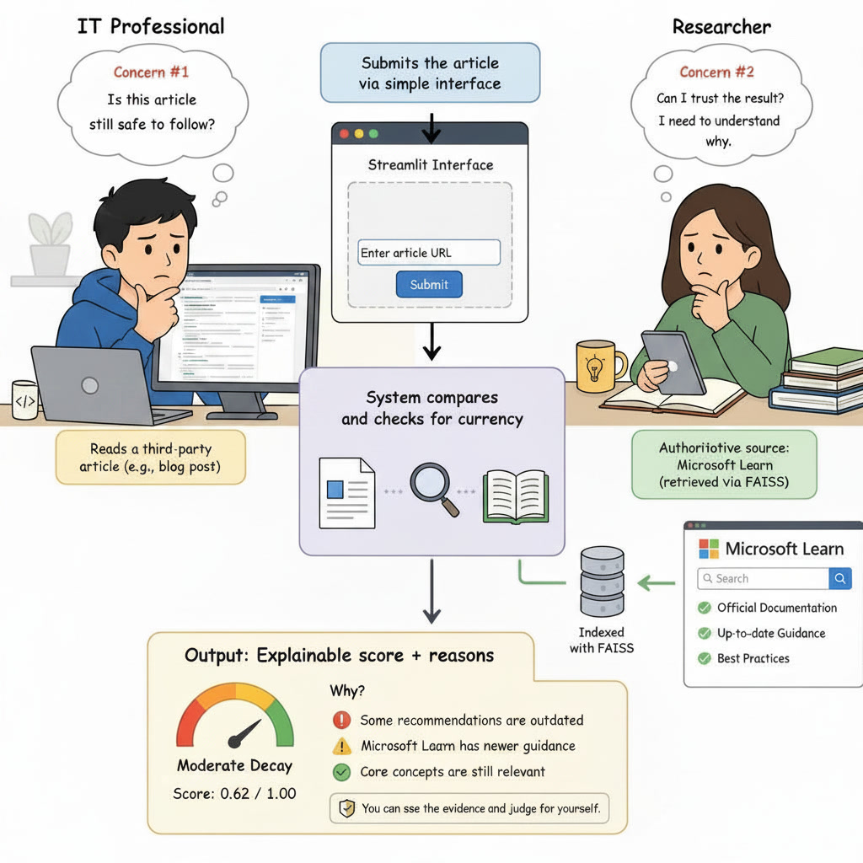
Figure 1.1 presents a rich picture of the proposed solution, showing the key stakeholders, the flow of information between them, and the central concerns that shape the design of the framework.

Figure 1.1:Rich picture of the proposed Knowledge Decay Framework

The image focuses on two stakeholders and two issues. The first stakeholder is an IT professional located to the left, who is looking over a third party technical document and thinking about if the information provided in that document is still valid. The second issue that is driving the systems design is that the article provides no indication of when the information may have been outdated; there are generally no indications of how old a blog post is.
The IT professional will submit the article to the system using a Streamlit interface. That article will then be passed to the Multi-Signal Knowledge Decay Framework found in the center of the image. The Multi-Signal Knowledge Decay Framework will compare the article provided by the IT Professional to Microsoft Learn, which is shown to the right as the "authoritative" reference for this type of material. To do so, Microsoft Learn was searched via FAISS and indexed.
Unlike other scoring systems where the output would simply be a numeric value, the Multi-Signal Knowledge Decay Framework will provide both a numeric value representing an explanation of why the articles were scored as they were, along with the reasons behind those scores. This represents the second concern illustrated in the image that researchers wish to ensure that the results produced by the system will be defensible rather than relied upon without question. This concern is directly related to the consideration expressed in Section 2.8. Results from research done under the FRESCO project (An et al., 2026) indicated that retrieval-based methods can also be influenced by older versions of documents that resemble newer versions stylistically; as such, a non-transparent score may result in an incorrect score, one that a user has no way of identifying as being incorrect. Therefore, making the rationale used for producing these scores transparent is not merely an aesthetic decision regarding how the system should look, but is instead a response to risks identified in existing literature.

Resource Requirements
Table 1.1 sets out the hardware and software resources required for this project, each with its specific justification. As the researcher is familiar with Microsoft 365 & Azure Infrastructure and Windows Server but not with software development, resources that are well-documented, widely supported, require the least amount of custom low-level engineering, and therefore would be easier to get correct, were given priority.
Table 1.1:Resource requirements
Resource | Category | Justification
Development laptop/workstation (minimum 16GB RAM) | Hardware | Sufficient for local inference of lightweight embedding models such as SBERT without requiring a dedicated GPU
Reliable broadband internet access | Hardware | Required for retrieving Microsoft Learn documentation and third-party test articles during development and evaluation
Microsoft Azure subscription | Hardware | Reserved for compute-intensive or longer-running tasks, such as bulk corpus embedding, that exceed local hardware capacity
Python 3.x | Software | Primary development language, chosen for its dominant machine learning and NLP ecosystem
Hugging Face Transformers library | Software | Provides pre-trained access to SBERT and DPR models without training a model from scratch
FAISS (or ChromaDB) | Software | Vector similarity search against the authoritative corpus, established in production-scale retrieval systems (Johnson, Douze and Jegou, 2019)
BeautifulSoup | Software | HTML content extraction from third-party articles
scikit-learn | Software | Weighted decay-scoring model, chosen for accessibility and transparency over a custom-trained classifier
Streamlit | Software | Prototype user interface, allowing a functional interface without front-end development skills
Git and GitHub | Software | Version control and an auditable history of the project's development

Project Scope
The research, as described in section 1.3.4, focuses on a defined area with limited boundaries instead of addressing the overall issue of knowledge decay within enterprise content. The focus on a specific area was based on the constraints of time required to complete an MSc project, and the necessity to compare the framework using a single authoritative source (as mentioned in section 2.7) versus multiple unverified authoritative sources that would require the determination of their respective authority. Table 1.2 clearly outlines the boundaries of this research by defining what is included in the scope of this project as opposed to what is excluded from it.
Table 1.2:Project scope
In Scope | Out of Scope
Single-article analysis via URL or pasted text input | Browser extension or other live, at-the-point-of-use deployment (identified as future work)
Comparison against Microsoft Learn as the authoritative source | Support for authoritative sources beyond Microsoft Learn
Multi-signal scoring: semantic similarity, terminology drift, broken links, deprecated technology, temporal metadata | Multi-language support
Explainable score output with contributing reasons | Automatic correction or rewriting of decayed content
Evaluation via a labelled dataset using precision, recall, F1-score and an ablation study | Real-time monitoring or alerting of a live, continuously updating knowledge base

The items that were placed outside of the current scope of this study will not be treated as non-relevant or unimportant. The three most relevant (the browser extension) are discussed below as two possible paths for future development, after the stand-alone scoring engine is developed and evaluated. Keeping the focus of the current study on a single, trusted authority, and one article at a time, keeps the research question tractable and requires that all aspects of the proposed multi-signal model be fully realized through design, implementation and evaluation.

Chapter Summary
This Chapter has introduced the problem of knowledge decay in enterprise technical documentation and placed that description into the context of Enterprise Knowledge Management (EKM). It then narrowed down to a formally stated problem statement.
The research question, motivation, aim & four supporting objectives were established; and a rich picture of the proposed solution was provided along with an outline of the resources needed to achieve it; alongside identification of the project boundaries.The next chapter will provide a review of the existing literature related to this problem to define the specific gap that this research aims to addres.

. Literature Review

Chapter Overview
This chapter reviews literature relevant to the detection of knowledge decay in enterprise technical documentation. It begins with providing a domain overview as a way to frame the larger context of Enterprise Knowledge Management.After the domain overview, it undertakes an examination of systems, frameworks and design approaches that are relevant to the current challenge of detecting knowledge decay. Following this, the chapter undertakes a technology analysis at three levels; algorithmic, design and workflow to provide greater insight into those technologies that have been identified as being most appropriate to addressing this issue. Finally, the cchapter includes a critical analysis which identifies where the specific research gap of this sstudy lies, and reflects upon how the review informed the design of the research.

Conceptual Taxonomy of Literature Organisation
The literature examined within this research spans three levels of abstraction. Firstly at the domain layer the body of literature defines why knowledge decay is a serious and expensive issue to companies within enterprises. Secondly at the system layer the body of literature explains current tools and techniques (e.g. Retrieval-Augmented Generation; Enterprise AI Assistants) which are related to but have yet to resolve the decay detection problem. Finally at the technology layer, the literature explains the technical detail regarding the algorithmic approaches, design patterns and workflow designs used to build those systems with the intention of using them as a foundation for this study's work. This chapter will describe each of these three layers in sequence to establish a single identified research gap.
Figure 2.1 illustrates this three-level organisation as a concept map, showing how the specific systems and techniques reviewed in this chapter relate to one another and converge on the research gap identified in Section 2.8.

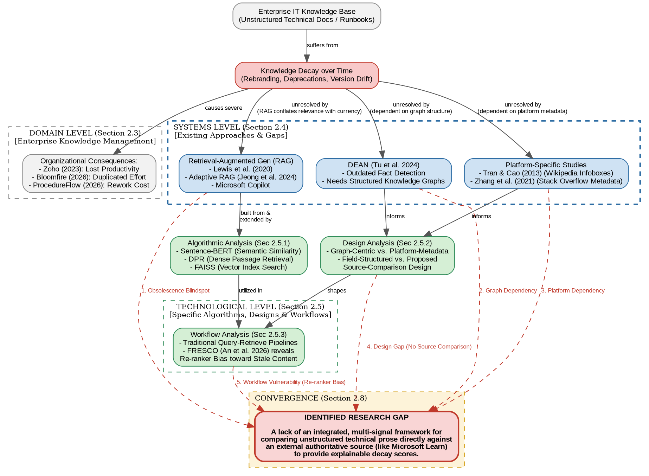

Figure 2.1:Concept map of literature review organization

Domain Overview
Enterprise Knowledge Management (EKM) enables organizations to gather and organize knowledge in order to better accomplish tasks and make decisions. The increasing use of Cloud technology, Artificial Intelligence and Digital Transformation will continue to make it difficult for organizations to keep their knowledge up-to-date due to continuously updating software, new security practices, renaming products and new usage guides - all factors leading to “Knowledge Decay” (Tu et al. 2024). Sources from within industries confirm that this is an expensive issue, as well as being an inconvenience, as poor Knowledge Management has caused great loss of productivity and rework (Procedure Flow 2026; Zoho 2023; Bloomfire 2026). Although the use of NLP, Semantic Search and RAG has allowed Enterprises to find the existing knowledge they need (Lewis et al. 2020; Gao et al. 2023), the fact remains that retrieving knowledge does not automatically mean that the knowledge is valid, current or reliable.
It has to be noted that most of the empirical data supporting the concept of the "cost of knowledge" decay are based on studies produced by vendors and industry sources which may have less credibility than academic research. However, despite the commercial source of these studies' estimates, there is a similar pattern presented in both sets of studies when compared to the more scientifically-based platform-specific studies to follow in Chapter 2, section 2.4. Additionally, the domain-based studies of knowledge management view knowledge management mostly as an internal organisational issue and infrequently distinguish between the decline in an organisations own documentation and the decline of external, third party technical information that IT professionals use and rely upon but cannot control. The distinction between organisational and external documentation does not exist at the domain level; however, this distinction will become critical when studying the systems-level literature in Chapter 2, section 2.4.
Microsoft’s own cadence on how frequently they are releasing new versions, whether as updates to current products or entirely new ones, is indicative of how fast a company can create this type of pressure when a large enough number of customers start using these features in production. For example, from 2023 through 2025, Microsoft will have changed the brand name of “Azure Active Directory” to “Microsoft Entra ID”, moved hundreds of pages of security & compliance documentation into an area called Microsoft Purview, and removed or re-named dozens of portal blades and PowerShell modules used within many technical articles written before. The problem isn’t that each individual change will automatically update every article written previously regarding the older version of the product; rather, once those changes occur, all those old articles remain unchanged (and silent), without any mechanism for either Microsoft or anyone else to know if/when one of those changes occurred.
This pace of change is not specific to Microsoft; the rapid evolution within the software industry is due in part to the emergence of continuous delivery (in contrast to previous practices) as more companies are transitioning their cloud-based services to provide updates continuously, typically on a weekly or daily basis instead of using the traditional method of releasing new versions every so often. In addition to providing a clear indication of what a particular version represented, the use of a version number in articles (such as "Version 2019") was also indicative of when an article needed to be revised. The continuous model of delivering updates removes this versioning, leaving only a reference point of how current the information is today and when it was last published.

Existing Systems, Frameworks and Designs
The Retrieval-Augmented Generation (RAG) method uses a combination of large language models and semantic search methods to increase the number of accurate facts and decrease the occurrence of hallucinations in the generated answers (Lewis et al., 2020). The RAG-Adaptive version improves upon this model through dynamic adjustment of the search parameters based on the type of question asked, increasing its ability to answer complex business questions that are often required in enterprise environments (Jeong et al., 2024). Enterprise AI assistants (i.e., Microsoft Copilot) can utilize similar systems to allow users to perform semantic searches for information from their organization using natural language. While all these systems have improved upon traditional retrieval methods for retrieving relevant information; but none evaluates whether the retrieved information is itself outdated.
Adaptive RAG uses the adaptive process of sending queries to the correct complexity tier, either non-retrieval, a single-step retrieval, or multi-steps retrievals and sends those queries to the appropriate location, so that it does not have to retrieve all passages equally once they are retrieved. Microsoft Copilot operates in a way that is largely similar in terms of products: It utilizes the organisation's data contained within the Microsoft Graph Index and creates a synthesized response using references back to the original data sources. The ground created by Copilot on each reference actually increases the ability of users to follow the path from the reference to the referenced document than if there were no references; however, Copilot lacks a means to evaluate independently whether the referenced document will remain current when queried again. Therefore, users who do not open the referred-to document after being given the reference inherit the same risk that this study identified.
This is particularly relevant to the enterprise IT professional this research aims to target and distinguish them from other consumers: IT Professionals typically verify against several different resources simultaneously- the vendor’s documentation, internal wiki pages, and third-party blog entries and they use these resources to perform verifications based upon pre-existing habits of verification. Therefore, IT Professionals would be the ones most likely to take action based on an overt indication of content obsolescence that was provided. The type of people who could utilize Copilot or similar assistants are far less specialized and represent a much wider population.
There are many examples of prior art that identify and/or mitigate content obsolescence; however, all of those that exist today are designed around particular types of data structures. For example, Tu et al. (2024), proposed DEAN, a Deep Learning System capable of identifying outdated facts within Knowledge Graphs. However, since DEAN uses a deep learning approach to identify outdated fact, it requires structured representation of knowledge graphs where enterprise articles do not possess. Similarly, Tran and Cao (2013) identified outdated information in Wikipedia Infoboxes using the same type of structured representation used in Wikipedia Infoboxes. Lastly, Zhang et al. (2021), studied Obsolete Answers on Stack Overflow at large scales and found that over 50% were already outdated when initially published. However, the detection process utilized user comments and platform-specific metadata that would be unavailable outside of Stack Overflow. These studies demonstrate that content obsolescence can occur and that it can be detected. However, each of the studies demonstrated that there exists no single solution that can apply to an arbitrary third-party technical article.
It is also instructive to consider how this class of system is typically evaluated, since this has a direct bearing on the evaluation strategy adopted later in this study. The classification of outdated fact or content has been viewed as a classification task by researchers within this field of study, which is then compared to a ground truth labeled collection of known outdated and known current documents using common assessment metrics such as precision, recall and F1 score. In addition, researchers have frequently employed manual labeling of content (i.e. determining if a document is outdated) to create their own collections for comparison purposes. These two approaches (metric based assessments and manual labeling) were applied to the development of the ground truth labeled data set created for this research. As was recognized in Chapter 6 (the chapter describing the creation of the labeled data), manual labeling can sometimes be ambiguous and therefore requires careful consideration.

Technological Analysis

2.5.1. Algorithmic Analysis
At the algorithmic level, Sentence-BERT (SBERT) produces sentence embeddings via a siamese BERT architecture, allowing two pieces of text to be compared for semantic similarity far more efficiently than the original BERT model, which requires both texts to be passed through the network together (Reimers and Gurevych, 2019). This efficiency is what makes SBERT practical for comparing a submitted third-party article against a large authoritative corpus in near real time. However, SBERT's output is a single similarity score between two embeddings, and similarity is not the same property as currency: two passages describing the same feature can be highly similar to one another whether both are current, both are outdated, or one of each. SBERT can therefore identify which authoritative passage a third-party article most closely corresponds to, but it cannot, on its own, determine whether that correspondence reflects agreement with current guidance or simply agreement with guidance that has since changed together.
FAISS (Facebook AI Similarity Search) enables both methods to be executed efficiently at large scales (Johnson et al., 2019). Instead of comparing a query-embedding with each document-embedding individually within a corpus for similarity, FAISS builds an index that supports both exact and approximate nearest-neighbour search, including on hundreds of millions of vectors. This project uses the exact index, because its corpus of about 123,000 chunks is small enough to search exactly..
A further algorithmic consideration, relevant to how these components are combined rather than to any one of them individually, is threshold calibration. Both SBERT and DPR provide continuous similarity scores instead of discrete judgments regarding similarity. As a result, there needs to be some type of cutoff established to determine at what level the two passage similarities are sufficient to consider they describe the "same" underlying guidance. Unfortunately, this project found that no universally accepted thresholds have been identified within the existing research to apply across all domains. Therefore, while a threshold may be determined based upon general-purpose text corpora, it does not guarantee reliable performance with enterprise cloud terminology. In addition to the fact that different wording (such as changing a product name) in enterprise cloud terminology can be semantically significant, regardless of the resulting high raw similarity score. Thus, this project will treat threshold calibration as an empirical process to be developed using its own evaluation data set, described in Chapter 6, rather than relying on an unqualified use of a previously established default threshold.

2.5.2. Design Analysis
Beyond algorithms, three distinct design patterns for addressing content obsolescence are reflected in each of the systems reviewed above.
DEAN's graph-centric design approaches obsceness by reasoning about relationships between structured entities and is limited to detecting obscenness on target content that exists as a knowledge graph.Zhang et al. (the authors of the Stack Overflow study) employed a platform-metadata design approach; obsolescence was determined indirectly based upon various signals generated by a particular platform (i.e., comments on answers identifying them as "outdated") as opposed to signals generated directly by the content itself. Tran & Cao employed a field-structured design; their system relies upon Wikipedia's infobox format to identify clearly delimited attribute/value pairs which can be compared over time. Each design achieved high levels of accuracy through the exploitation of structural properties that are specific to each domain.This project will employ source comparison design; the target content will be treated as unstructured prose and evaluated by comparing it directly against an external authoritative source rather than relating on any structure or platform-specific signal provided by the target content.
A helpful method to characterize the differences among the various designs is based on location of their single source of truth. The DEAN approach uses its single source of truth located within the knowledge graph (that is, when relationships that express facts are created in a graph, they become self consistent with respect to internal logic; therefore, when an old fact is identified, it can be done by checking relationships against other relationships). Similarly, the platform metadata design used in Zhang et al. will use the surrounding community as a means of identifying if an infobox is no longer valid, through accepting a critical comment as evidence of invalidity instead of checking the content of the comment. As such, neither DEAN nor Zhang et al. approaches look outside of their respective systems for ground truth. This project adopted an alternative design methodology that was different from all of the prior methodologies solely on this point: it utilizes its single source of truth from an external and independent authority (Microsoft Learn), and does so regardless of whether it is using third party content to assess, the surrounding community, or its own edit history - all of which would likely be unavailable and/or untrustworthy for any arbitrary blog post.

2.5.3. Workflow Analysis
The systems reviewed also differ in their data workflow. A conventional RAG workflow proceeds query, retrieve, generate: a user question triggers retrieval of relevant passages, which are then used to generate a response, with no step that evaluates the age or accuracy of what was retrieved. DEAN's workflow proceeds extract entities, construct graph, verify facts against the graph, a pipeline that presupposes the graph-construction step has already happened. Zhang et al.'s workflow proceeds crawl posts, extract platform metadata, flag via community signals, a pipeline that only functions within a single platform's ecosystem. FRESCO (An et al., 2026) contributes a further workflow-level finding relevant here: their benchmarking shows that a re-ranking step, if not explicitly corrected for it, can systematically favour older content that is stylistically similar to current content over genuinely current content, meaning workflow ordering itself can introduce decay-blindness rather than only the absence of a decay-detection step. The workflow this project proposes departs from all of these by design: extract content, identify topic, retrieve the corresponding authoritative passage, evaluate multiple decay signals in parallel, and combine them into a single explainable score, a sequence that depends only on the third-party content and the authoritative source being compared, not on any platform-specific or pre-structured data being available.
FRESCO's benchmark demonstrates the workflow effect in question empirically: it combines recency seeking queries with Wikipedia revisions from previous times, allowing a re-ranker to choose between a passage representing current knowledge and an actual older version of the same passage that is factually outdated yet both historically and stylistically consistent with the query (An et al., 2026). Their testing showed this occurred frequently enough to represent a systemic issue, and therefore a workflow level finding vs. purely algorithmic; the base similarity computation was presumably correct and still failed due to the placement of a scoring stage within a process pipeline relative to when content being presented was initially ranked. For the purpose of this project there is one limitation of interest regarding FRESCO's evaluation: their testing was performed using Wikipedia revisions and not enterprise technical documentation, so while we can assume some degree of empirical confirmation will occur as to the size or scope of this bias within a technical documentation context - we cannot confirm it directly at this time. As such, the workflow identified by An et al. (2026) has a direct design implications for the present project: a workflow designed solely upon evaluating semantic similarities for all rankings could have a similar type of bias. This is why the workflow developed for this project includes evaluating multiple decay signals in parallel rather than simply relying upon ranking based upon semantic similarity.

Reflection
Table 2.1 synthesises the individual sources reviewed across Sections 2.4 and 2.5, recording for each what it contributes, and an explicit judgement of its impact on the framework proposed in this study.
Table 2.1:Reflection - synthesis of individually reviewed literature and its impact on this research
Citation | Description | Impact on This Research
Lewis et al. (2020) - RAG | Combines retrieval with generation to ground LLM outputs in retrieved passages. | Favourable-low: establishes the retrieve-then-use pattern this project follows, but has no currency check to build on directly.
Jeong et al. (2024) - Adaptive-RAG | Adjusts retrieval strategy dynamically based on query complexity. | Unfavourable-low: relevant retrieval technique, but adaptive strategy selection is not a problem this project needs to solve.
Reimers and Gurevych (2019) - SBERT | Siamese BERT architecture producing efficient sentence embeddings for similarity comparison. | Favourable-high: adopted directly as this project's primary semantic-comparison mechanism.
Karpukhin et al. (2020) - DPR | Dual-encoder architecture for passage retrieval in open-domain question answering. | Favourable-low: considered as a secondary retrieval option; domain-transfer limitation reduces confidence in using it as primary.
Johnson, Douze and Jegou (2019) - FAISS | Nearest-neighbour search infrastructure (exact and approximate) for large-scale vector comparison. | Favourable-high: adopted directly as this project's vector-search infrastructure.
Tu et al. (2024) - DEAN | Detects outdated facts within structured knowledge graphs. | Unfavourable-low: confirms decay detection is feasible, but its graph-dependent design cannot be reused for unstructured prose.
Tran and Cao (2013) - Wikipedia infoboxes | Detects outdated attribute values in Wikipedia's structured infobox fields. | Unfavourable-low: same limitation as DEAN; format-specific design does not generalise to this project's input.
Zhang et al. (2021) - Stack Overflow study | Empirically shows over half of obsolete Stack Overflow answers were outdated when first posted. | Favourable-low: strong evidence the underlying problem is real and severe, though its platform-metadata detection method is not reusable here.
An et al. (2026) - FRESCO | Benchmarks re-ranker bias toward older, stylistically similar but factually obsolete documents. | Favourable-high: directly justifies this project's explainable, multi-signal design over a single opaque retrieval score.
Yu et al. (2026) - Knowledge Integration Decay | Shows models can fail to integrate correctly-retrieved current knowledge into their reasoning. | Favourable-low: reinforces the case that retrieval quality alone is insufficient, supporting this project's broader motivation.

These entries indicate that there is a uniform structure when examining them as a group; those algorithms having the most favorable influence on the system were either direct building blocks of an algorithm used by this project (FAISS, SBERT), or they provided evidence motivating both the problem itself and how it should be designed (Zhang et al., FRESCO), while all of the other decay-detection systems have a structural dependency (Tran and Cao, DEAN), which was useful for proving the existence of the problem, but not usable as a reusable method. The results from these observations justify the design choice that will be discussed in section 2.8, to develop a comparison framework among different data sources instead of adapting one existing method.
The FRESCO results (An et al., 2026) also have an important implication outside of the table above. They demonstrate how retrieval may favor older, outdated content if the new content uses a style similar to that of the older content. Therefore, a system based solely on retrieval would likely provide a false positive. Figure 2 identifies this as the workflow vulnerability, the fifth pathway to the gap. This is one reason for the design of the proposed framework’s output being explanatory versus providing only a number. A reader has no ability to verify a score using just a number. However, by providing details about what specifically caused the score - e.g., “broken link,” “deprecated terms” , provides readers with enough detail to challenge suspect results.

Comparison of Existing Approaches
The systems and methods reviewed in this chapter are summarised in Table 2.2 in relation to the specific requirements of the problem this research addresses. These requirements include the ability to work with unstructured, free-form technical prose, the ability to compare the output to an external authoritative source, and the ability to produce an explainable rather than opaque output.
Table 2.2:Comparison of existing retrieval and decay-detection approaches
Approach | Primary Purpose | Unstructured Prose | External Source | Explainable
RAG (Lewis et al., 2020) | Knowledge-grounded generation | Yes | No | No
Adaptive-RAG (Jeong et al., 2024) | Adaptive retrieval strategy | Yes | No | No
SBERT (Reimers & Gurevych, 2019) | Semantic similarity | Yes | Yes (similarity only) | Partial
DPR (Karpukhin et al., 2020) | Passage retrieval | Yes | Yes (retrieval only) | No
DEAN (Tu et al., 2024) | Outdated fact detection | No - needs graphs | Yes | Partial
Tran & Cao (2013) | Outdated attribute detection | No - needs infoboxes | Yes | No
Stack Overflow study (Zhang et al., 2021) | Obsolete answer analysis | Partial - platform-dependent | No | No
Enterprise AI Assistants (e.g. Copilot) | Semantic enterprise search | Yes | No | No

The table shows how each of the methods shown in the table can be used to solve at least part of the problem with using external sources to verify facts. When looking down the Unstructured Prose and External Source columns as a pair (simultaneously), it is clear that there is no method in the table which will meet all three criteria. S-BERT meets the prose criterion, but only measures similarity to an external source, not whether the information was current. DEAN and Tran and Cao's Infobox Method meet the External-Sourced criterion, but only measure against structured information. The Enterprise-Facing Systems (RAG, Adaptive-RAG, Copilot-Class Assistants) meet none of the three, because their primary focus is on measuring the quality of retrieval, not verifying the sources. The Explainable Column adds to this observation by noting that even those methods that have met some of the other two criteria partially, produce either a similarity score, or a binary fact-verified result, and not a structured list of reasons why you may want to take action based upon your findings. Thus, the three gaps identified above - unstructured input, comparing to external sources, and providing explanations - are exactly what the Framework described in this paper seeks to address, and no one row from Table 2.2 addresses more than one or two of the gaps.

Critical Analysis and Research Gap
Enterprise knowledge management systems currently in use, including AI-powered assistants, are built to rapidly identify relevant information, not to determine whether that information has been updated to reflect current vendor guidance. This is a blind spot of real consequence, which Figure 2.1 labels the obsolescence blindspot. Prior research shows that obsolete knowledge negatively affects both human decision-making (Zhang et al., 2021) and AI systems' ability to reason correctly (Luu et al., 2022; Yu et al., 2026).
The wider literature treats semantic similarity, passage based retrieval and outdated content identification independently from one another, in their respective contexts. Both SBERT and DPR offer a common mechanism for comparison and retrieval; however neither offers an intrinsic method for defining currency. Both the Wikipedia Infobox (which provides a means for identifying decay) and DEAN (provide a similar capability); however both require some level of pre-existing structure on the target content, which technically oriented prose lacks. Figure 2.1 labels this the graph dependency. Zhang et al., show that this issue can be identified at scale through use of platform specific signals; however these signals are unlikely to enable analysis of an independent blog post. Figure 2 traces this as the platform dependency.
There are valid arguments that a previously developed RAG pipeline could reasonably approximate the concept of currency through simply retrieving more recently published or most recently updated documents as part of the process. The previous research cited in the literature review does not support the use of recency as a proxy for currency. Both Luu et al. (2022) and Yu et al. (2026), found that recency cannot serve as a proxy for currency; it is possible to retrieve a document with a recently published/retrieved passage that contains outdated information because the passage contained information from an older source. Conversely, it is also possible to have current information within a document that has not been modified recently. Therefore, using recency based filtering would provide a related but distinct issue to addressing the problem itself, a design gap that Figure 2.1 traces back to every system reviewed in Sections 2.4 and 2.5, and will not identify the same type of explanation.
This review found no work that integrates semantic comparison, terminology and version drift, reference integrity, and deprecated-technology detection into a single framework designed specifically to compare third-party technical content against an authoritative external source, and that produces a transparent, explainable result rather than a single opaque similarity figure. That is the specific gap this research addresses. Figure 2.1 traces how these five pathways all converge on that same point: the obsolescence blindspot, the graph dependency, the platform dependency, the design gap, and the workflow vulnerability.
This gap has a practical effect that needs to be stated: in its absence, an it professional currently does not have any automated way of telling if a third-party article is reliable or outdated and must either manually check every claim against vendor documentation which is time-consuming and easily skipped when under deadline pressure or simply trust the appeared authority of the article (length, technical detail, professional formatting) which do not indicate whether the guidance given by the article is still current. Closing this gap will not require solving knowledge decay in general but will only require that the specific comparison between one third-party article and one authoritative source be made automatic, explainable, and reliable enough for the default behavior to change.

Chapter Summary
This chapter has reviewed literature across three levels of abstraction: the domain-level context of enterprise knowledge management, existing systems and frameworks including Retrieval-Augmented Generation and enterprise AI assistants, and a deeper technological analysis of the algorithms, design patterns and workflows underpinning current approaches to related problems. The review also showed that there is currently no system using all of semantic comparison, terminology, version drift, reference integrity and detection of deprecated technologies to provide a single framework for explanation on how to compare third-party technical content against an authoritative external source - the specific gap this research addresses. The methodology adopted to address this identified gap will be presented in the next chapter.

. Methodology

3.1 Research Paradigm
A research paradigm defines the underlying philosophical assumptions about the nature of reality and how knowledge about that reality can be obtained. Of the paradigms commonly distinguished in information systems research – positivism, interpretivism and pragmatism (Oates, 2006) – this research adopts a pragmatist paradigm. A purely positivist stance has some appeal, since the framework's output is a measurable score validated against precision, recall and F1, but is difficult to sustain in full, since the ground-truth labels that evaluation depends on are themselves the product of human judgement about what counts as "decayed". A purely interpretivist stance would also be insufficient, since the research question specifically requires a measurable, comparative claim about detection performance rather than a rich contextual account. Pragmatism is consistent with the Design Science Research orientation established in Chapter 1 (Hevner et al., 2004; Peffers et al., 2007), which is concerned primarily with whether an artefact works to solve a genuine practical problem rather than with adherence to a single philosophical position.

3.2 Research Approach
Of the research approaches commonly available – deductive, inductive and criss-cross/abductive (Saunders, Lewis and Thornhill, 2019) – this research adopts a deductive approach. The starting point is not an open-ended observation but a specific, literature-derived expectation, established in Chapter 2: that no single existing signal is sufficient on its own to detect decay in unstructured third-party technical content, and that combining multiple complementary signals should outperform any single-signal baseline. This expectation is then tested empirically in Chapter 6 through a structured comparison between the proposed multi-signal framework and single-signal baselines.

3.3 Research Strategy
Of the strategies commonly available – experimental, action research, case study and phenomenology (Oates, 2006) – this research adopts an experimental strategy, since it involves constructing an artefact and measuring its effect against a defined baseline. Action research was not selected because it requires an iterative intervention within a real organisational setting with ongoing stakeholder participation, which is outside the scope defined in Section 1.10. Case study and phenomenology were not selected because both are oriented toward rich, context-specific qualitative understanding of a single instance, whereas this research requires a generalisable, measurable comparison across many articles.

3.4 Fact Collection Mechanisms
Of the fact collection mechanisms commonly available – questionnaires, interviews, controlled interviews, expert opinions, participation assessment and focused discussion (Oates, 2006) – this research relies on expert opinion alone, used narrowly. As established in the Ethics Form completed for this project, this research does not collect data from human participants, which rules out the remaining options; this decision was made deliberately, since introducing any participant-based data collection method would have required a materially different ethics approval process and would not have been necessary to answer the research question, which concerns the performance of an artefact against a labelled dataset rather than the opinions or behaviour of a population of people. Where expert opinion is used, it takes the narrow form of an optional secondary review of a sample of the ground-truth labels applied to the evaluation dataset, to sense-check the primary labelling rather than to gather new data from participants; this narrow use does not constitute research involving human participants in the sense the Ethics Form screens for.

3.5 Research Methodology Execution Workflow
Table 3.1 summarises how each stage of the overall research process has been, or will be, addressed, and identifies where in this dissertation each stage is documented in full.

Table 3.1:Research methodology execution workflow
Stage | How Addressed | Documented In
Problem Identification | Identification of knowledge decay as a documented, costly and currently unresolved problem for enterprise IT documentation | Chapter 1
Relevance Justification | Grounded in industry evidence of the cost of poor knowledge management and in academic evidence that stale content degrades both human and AI decision-making | Chapter 1, Section 2.3
Comparative Analysis and Gap Justification | Systematic review and comparison of existing systems, algorithms, design patterns and workflows relevant to content-decay detection | Chapter 2
Define and Finalise Objectives | Four research objectives derived directly from the identified gap, each mapped to a specific deliverable | Chapter 1, Section 1.7
Design / Development / Data Management | System design (this chapter and Chapter 4), prototype implementation, and construction of the evaluation dataset under a defined data management plan | Chapters 3-5
Evaluation and Communication | Structured experimental evaluation against baselines and an ablation study, with findings communicated through the dissertation and viva | Chapters 6-7

3.6 Design Methodology
Of the design methodologies commonly available, this research adopts Object-Oriented Analysis and Design (OOAD) rather than Structured Systems Analysis and Design (SSAD) (Sommerville, 2016), since OOAD models the system as a set of collaborating objects with clearly defined responsibilities, which maps directly onto the framework's actual structure as shown in the Class Diagram in Section 4.6, and supports the use of UML throughout Chapter 4. This research therefore adopts OOAD exclusively and does not mix it with SSAD elements, since combining two design methodologies within a single system design would undermine the internal consistency of the UML models presented in this chapter.

3.7 Project Management Methodology
Of the commonly considered project management methodologies - Scrum, Kanban and PRINCE2 - this research adopts Kanban. Scrum was considered but not selected because its ceremonies and roles (Scrum Master, Product Owner, fixed-length sprints with sprint planning and retrospectives) (Schwaber and Sutherland, 2020) assume a team of contributors and do not map naturally onto a single-researcher MSc project; adopting Scrum’s full ceremony set for a project with only one contributor would add administrative overhead without a corresponding benefit. PRINCE2 was also considered and rejected as disproportionately formal and documentation-heavy for a project of this scale and duration. Kanban was selected because its core mechanism - a continuously visible backlog of tasks moved through states such as To Do, In Progress and Done (Anderson, 2010) - suits a single researcher managing an evolving set of build, evaluation and writing tasks without needing fixed iteration boundaries, while still providing a visual record of progress that can be reviewed at each scheduled supervision session, which serve as natural review checkpoints in place of formal sprint reviews.

3.7.1 Project Timeline
The project timeline, first presented in the proposal and reproduced here, is structured around the fixed supervision and submission schedule set by the module.

Table 3.2:Project timeline
Task | Jul | Aug | Sep | Oct | Nov
Proposal Approval | X
Literature Review | X | X
Framework Design | X | X
Dataset Collection & Labelling |  | X | X
Prototype Development |  | X | X | X
Experimental Evaluation |  |  | X | X
Results Analysis |  |  |  | X
Dissertation Writing |  |  | X | X | X
Final Review & Submission |  |  |  |  | X

3.7.2 LSEP Aspect (Legal / Social / Ethical / Professional)
Table 3.3 sets out how each LSEP dimension applies specifically to this research.
Table 3.3:LSEP analysis in relation to this research
Dimension | Application to This Research
Legal | Only publicly accessible third-party content is used, consistent with copyright and licensing terms; full article text is retained privately rather than republished, and the public GitHub repository excludes raw scraped content.
Social | The research aims to improve the reliability of technical decision-making within enterprise IT teams by reducing reliance on undetected outdated guidance.
Ethical | The framework evaluates documentation, not individuals or organisations, minimising bias and privacy risk; no personal or confidential data is collected, consistent with the completed Ethics Form.
Professional | Data integrity, accurate citation and reproducibility are maintained throughout; all technology and methodology choices are justified rather than adopted by default.

3.7.3 Risk Identification and Mitigation
Table 3.4 identifies the principal risks to this project and the corresponding mitigation adopted for each.
Table 3.4:Risk identification and mitigation strategy
Risk | Likelihood | Impact | Mitigation
Limited prior development experience delays implementation | Medium | High | Modular design with each component tested independently; supervision sessions used to validate design decisions before implementation begins
Evaluation dataset too small to yield statistically meaningful results | Medium | Medium | Dataset supplemented with systematically generated synthetic decay cases alongside genuine articles, discussed in Chapter 6
Microsoft Learn content structure changes during the project | Low | Medium | Authoritative corpus snapshot cached locally at a fixed point, rather than queried live, so results remain reproducible
Azure subscription budget exhausted before evaluation is complete | Low | Medium | Cloud resources reserved only for one-off bulk embedding tasks; day-to-day development performed on local hardware
Scope creep beyond the boundaries defined in Section 1.10 | Medium | High | Explicit in-scope/out-of-scope table agreed early and revisited at each supervision session before new work is undertaken

3.8 Chapter Summary
This chapter has set out and justified the methodological foundation of this research: a pragmatist paradigm, a deductive approach, an experimental strategy, and expert opinion used narrowly as the sole fact collection mechanism, consistent with the project's ethics scope. It has presented the research execution workflow, justified Object-Oriented Analysis and Design as the design methodology, and justified Kanban as the project management methodology, supported by a project timeline, an LSEP analysis and a risk identification and mitigation strategy. The next chapter translates this methodological foundation into a concrete system requirement specification.

System Requirement Specification

4.1 Chapter Overview
This chapter takes the problem described in Chapter 1 and the methodical decisions made in Chapter 3 and defines them into a clear description of what will make up this systems specifications. This chapter identifies the people that are impacted by this system, explains how the requirements have been identified based upon the ethical scope of the project and describes the systems behavior and structure via a collection of UML Diagrams: Use Case, Class, Activity and Sequence; along side a suggested System Architecture. The chapter closes with a synopsis of all functional and non-functional requirements for the system.

4.2 Stakeholder Analysis
Figure 4.1 presents the system's stakeholders using an onion model, which organises stakeholders by their proximity to the system rather than by a flat, unordered list (Alexander and Beus-Dukic, 2009). The center of the onion is the system itself. Those interacting with the system are found in the Operational Ring: the IT Professional, who has submitted articles and consumed results from the system, and the researcher, who has developed and evaluated the system. Those governing and evaluating the research but not operating the system are in the contextual ring: the module leader/supervisor, and university examiners attending the viva. Those outside the rings of contextual and operational are stakeholders affected indirectly or defining the environment that the system operates within: Microsoft as the maintainer of the authoritative source dependent upon for the systems operation, and enterprise organizations as the eventual recipients of more reliable technical decision making.

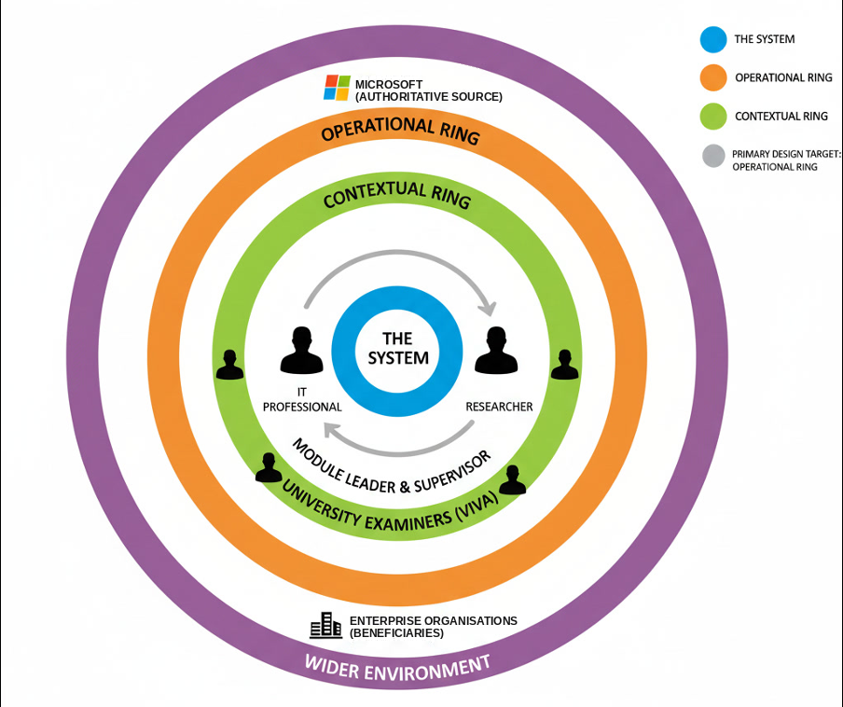

Figure 4.1:Stakeholder onion model

4.2.1 Implications of the Onion Model
The onion model has a direct design implication worth making explicit: the operational ring, not the wider environment, is this project's primary design target. The system is built to be used and evaluated by the researcher and to be usable by an IT professional; it is not built to directly serve Microsoft or the wider enterprise environment, which benefit only indirectly, through improved decisions made by IT professionals who use it. This distinction keeps the requirements in this chapter focused on the operational ring rather than expanding to satisfy stakeholders the project's scope, defined in Section 1.10, was never intended to reach.

4.3 Requirements Derivation Process
The generic process for deriving system requirements often involves a participant questionnaire, mapped against research objectives, with the reviewed results used to justify the validity of the selected requirements. This research adopts a deliberately different process, consistent with the fact collection decision justified in Section 3.4: because no questionnaires, interviews or other participant-based data collection are conducted, requirements are instead derived directly from the literature-identified gap established in Chapter 2 and the research objectives defined in Section 1.7, rather than from a participant survey. Table 4.1 makes this mapping explicit, tracing each requirement area back to the specific research objective and literature finding that motivates it.
Table 4.1:Mapping of requirement areas to research objectives and literature findings
Requirement Area | Research Objective | Literature Basis
Multi-signal decay detection (semantic, terminology, links, deprecated tech, temporal) | Objective 1: identify critical decay indicators | Section 2.5 - no single existing signal is sufficient alone
Semantic comparison against an external authoritative source | Objective 2: analyse semantic and authoritative-source comparison methods | Section 2.5.1 - SBERT measures similarity but not currency alone
Explainable output with contributing reasons, not a single score | Objective 3: implement an explainable prototype | Section 2.8 (FRESCO/An et al., 2026) - opaque scores cannot be checked by a user
Comparative evaluation against single-signal baselines and an ablation study | Objective 4: comparative evaluation against traditional methods | Section 2.6 - existing approaches evaluated using precision/recall/F1 against labelled data

4.4 Justification of Requirement Validity
In the absence of participant validation, requirement validity is instead established through direct traceability: every requirement in Section 4.11 can be traced, via Table 4.1, to a specific research objective and a specific literature finding, rather than to an unsupported design preference. Any candidate requirements which could not be traced back to the research objectives or the literature review are listed as being out-of-scope in table 2 (section 1.10) and therefore have been excluded from inclusion in the traceability shown above. The traceability of each of the requirements listed in this document is used as a surrogate for requirement validation and has been documented as such; however, this method of validation has limitations in that it demonstrates that each requirement is addressing a known problem area. However, it cannot demonstrate whether practitioners will prioritize those requirements in accordance with how they are described in the literature. Therefore, the fact that no additional validation beyond traceability has taken place regarding this point is documented in chapter 7 as one of the limitations of this study.

4.5 Use Case Diagram and Specifications
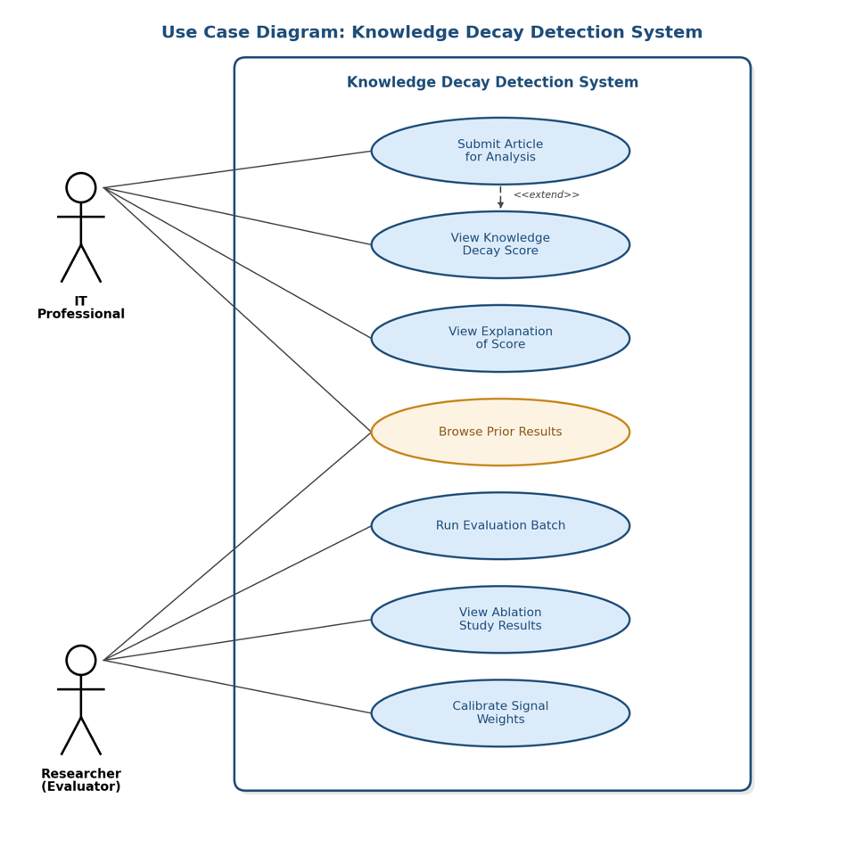
The system's use case diagram, illustrated in Figure 4.2, describes how the system interacts with its two operational ring actors: The IT Professional, who acts as the system's end-user; and The Researcher, who acts as the developer evaluating the system.

Figure 4.2:Use case diagram

4.5.1 Use Case Specification: Submit Article for Analysis
Table 4.2:Use case specification - Submit Article for Analysis
Field | Description
Actor | IT Professional
Preconditions | The system is running and the user has a URL or pasted text of a third-party technical article
Main Flow | 1. User opens the Streamlit interface. 2. User submits an article URL or pasted text. 3. System extracts and processes the content. 4. System returns a Knowledge Decay Score with explanation.
Alternative Flow | If content extraction fails (e.g. inaccessible URL), the system returns an error message rather than a score
Postconditions | A Knowledge Decay Score and explanation are displayed; the submitted article content is not persisted

4.5.2 Use Case Specification: Run Evaluation Batch
Table 4.3:Use case specification - Run Evaluation Batch
Field | Description
Actor | Researcher
Preconditions | A labelled evaluation dataset exists locally, as described in Chapter 6
Main Flow | 1. Researcher initiates a batch run against the evaluation dataset. 2. System scores every article in the dataset. 3. System compares predicted categories against ground-truth labels. 4. System reports precision, recall, F1-score and ablation results.
Alternative Flow | If a dataset entry cannot be processed, it is logged and excluded from the aggregate metrics rather than halting the batch
Postconditions | Evaluation metrics are produced and available for inclusion in Chapter 6
Detailed specifications for the remaining use cases shown in Figure 4.2 follow the same structure as Tables 4.2 and 4.3 and are provided in Appendix A, in order to document each use case in full while keeping the main chapter focused on the most significant cases.

4.6 Class Diagram
Figure 4.3 presents the core classes of the proposed framework and their relationships, following the Object-Oriented Analysis and Design methodology adopted in Section 3.6.
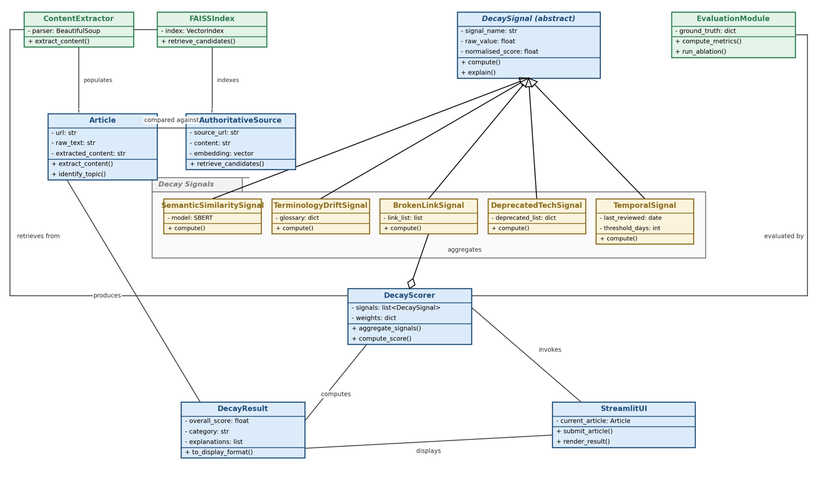

Figure 4.3:Class diagram

4.7 Activity Diagram
Figure 4.4 presents the end-to-end activity flow followed when an article is submitted for analysis, including the parallel evaluation of the five decay signals identified in Chapter 2 and the join point at which they are aggregated into a single score.

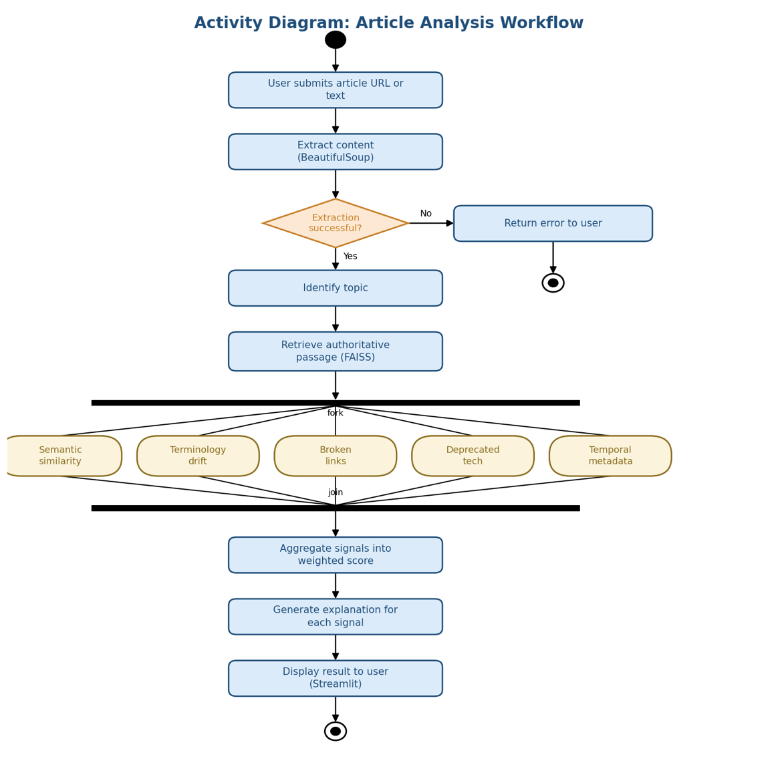
Figure 4.4:Activity diagram - article analysis workflow

4.8 Sequence Diagram
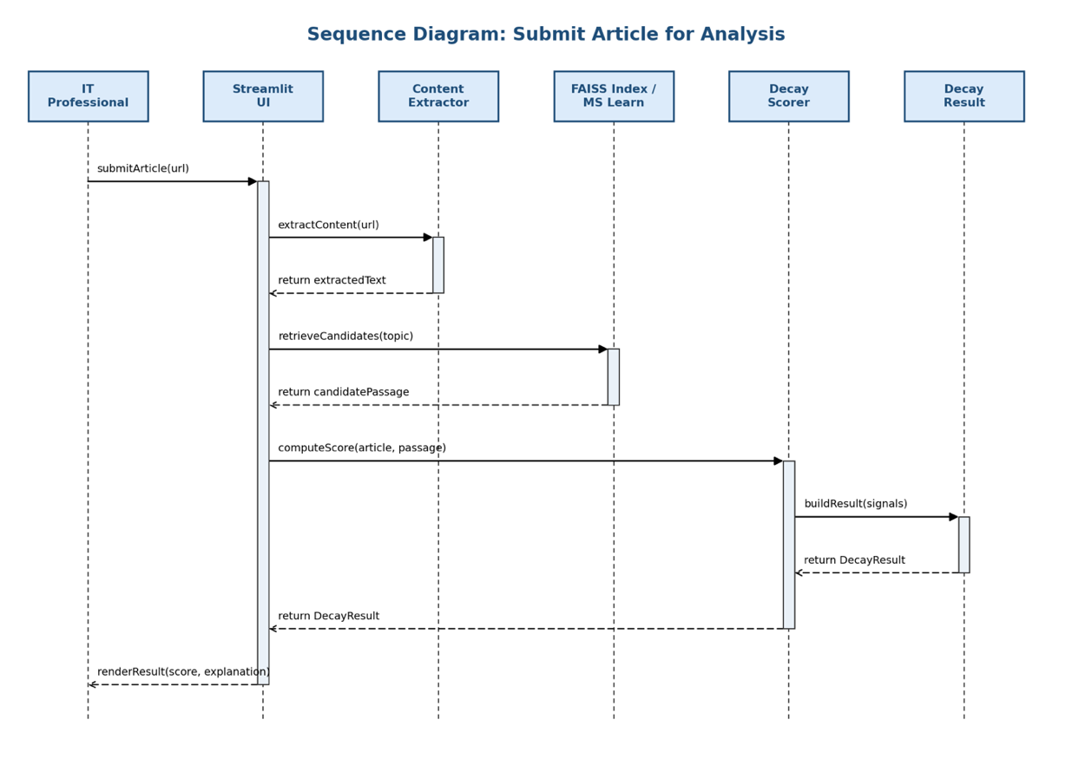
Figure 4.5 presents the sequence of interactions for the "Submit Article for Analysis" use case, corresponding to the specification in Table 4.2.

Figure 4.5:Sequence diagram - Submit Article for Analysis
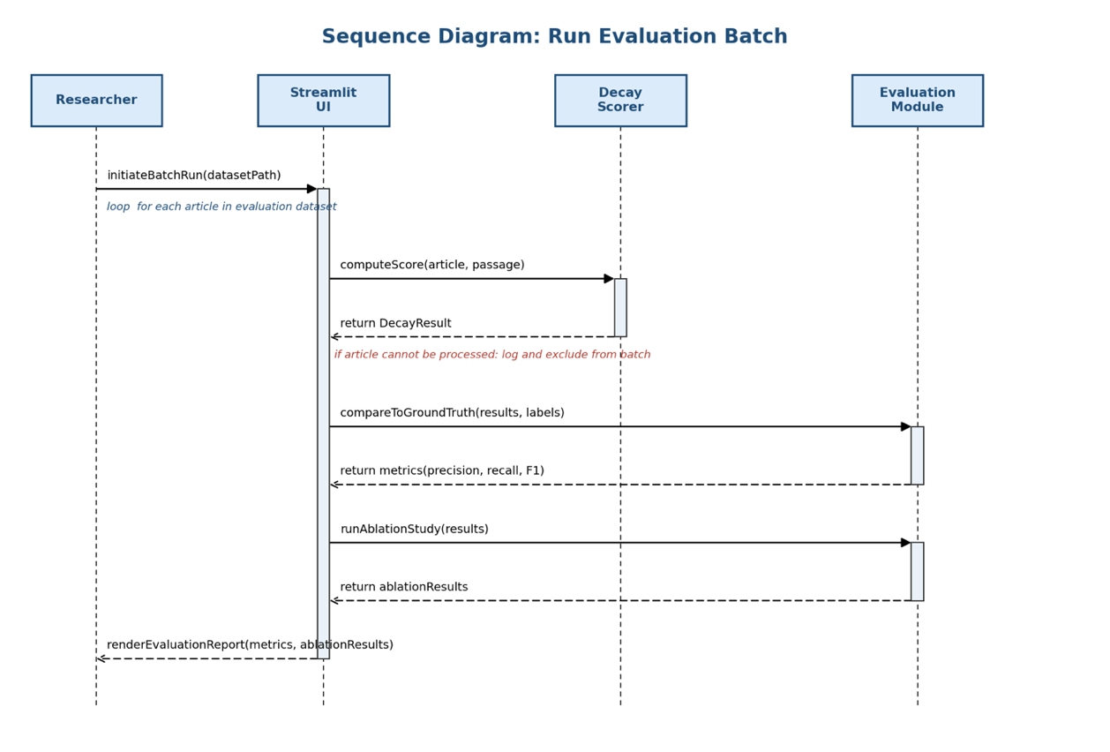
Figure 4.6 presents the sequence of interactions for the "Run Evaluation Batch" use case, corresponding to the specification in Table 4.3, initiated by the researcher.

Figure 4.6:Sequence diagram - Run Evaluation Batch

4.9 State and Deployment Considerations
A separate state chart or deployment diagram was considered but judged unnecessary for this system. The framework does not have entities with sufficiently complex internal state transitions to justify a dedicated state chart beyond what the activity diagram in Figure 4.4 already captures, and the deployment topology, a single Streamlit application running against a local or Azure-hosted environment, is straightforward enough to be adequately described in prose in Section 1.9 (Resource Requirements) rather than requiring a separate diagram.

4.10 Proposed System Architecture
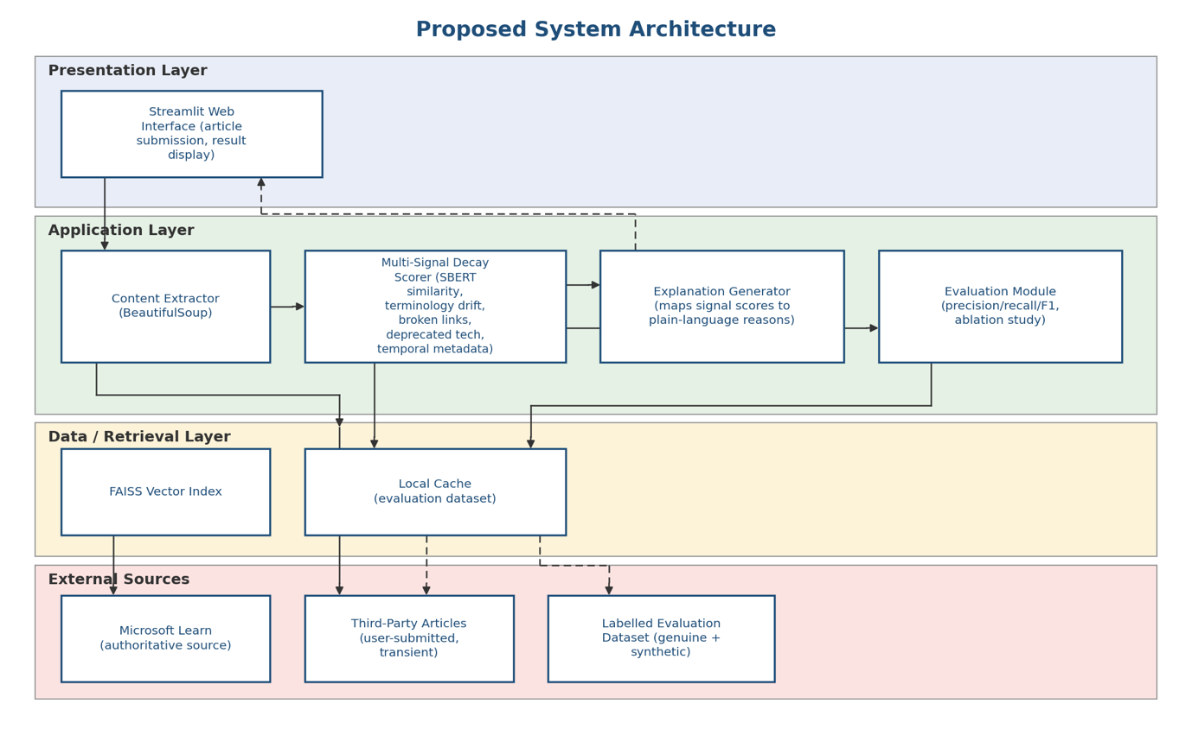
Figure 4.7 presents the proposed system architecture as a layered diagram, showing how the presentation, application and data/retrieval layers relate to each other and to the external sources the system depends on.

Figure 4.7:Proposed system architecture

4.11 Functional and Non-Functional Requirements
Table 4.4:Functional requirements
ID | Requirement
FR1 | The system shall accept a third-party article as either a URL or pasted text.
FR2 | The system shall extract the readable textual content from a submitted URL, excluding navigation, adverts and other non-article content.
FR3 | The system shall retrieve the most relevant corresponding passage from the Microsoft Learn authoritative corpus.
FR4 | The system shall compute a semantic similarity score between the submitted article and the retrieved authoritative passage.
FR5 | The system shall detect terminology drift by comparing product and feature names in the article against a maintained glossary of superseded terms.
FR6 | The system shall check all hyperlinks in the submitted article and identify any that are broken.
FR7 | The system shall check article content against a maintained list of deprecated technologies and features.
FR8 | The system shall check the publication or last-reviewed date of the submitted article against the corresponding authoritative source and flag articles that have not been updated within a defined currency threshold.
FR9 | The system shall combine all computed signals, including the temporal currency check, into a single weighted Knowledge Decay Score accompanied by its contributing reasons.
FR10 | The system shall present the score together with a plain-language explanation of the signals that contributed to it.
FR11 | The system shall not persist the content of an article submitted through the live interface beyond the current session.

Table 4.5:Non-functional requirements
ID | Category | Requirement
NFR1 | Performance | The system shall return a Knowledge Decay Score for a single submitted article within a reasonable interactive time frame on local hardware.
NFR2 | Usability | The system shall present results through a simple, single-page interface usable without developer-level technical knowledge.
NFR3 | Explainability | The system shall never present a Knowledge Decay Score without at least one accompanying, specific, human-readable reason.
NFR4 | Reliability | The system shall handle extraction failures gracefully, returning a clear error rather than an incorrect score.
NFR5 | Security/Privacy | The system shall not transmit or store submitted article content beyond what is required to compute and display a result.
NFR6 | Maintainability | Each decay signal shall be implemented as an independently testable component, consistent with the class design in Figure 4.3.

4.12 Chapter Summary
This chapter has translated the problem and methodology established in earlier chapters into a concrete system requirement specification. The chapter also used an onion diagram to identify the system’s stakeholders; it demonstrated how the requirements have been developed and verified without collecting participant-based data. Finally, it illustrated how the system will behave and be structured using a use-case diagram (with detailed specs for the two use-cases), a class-diagram, an activty diagram, a sequence diagram and a suggested system architecture. The chapter has also provided a list of both functional and nonfunctional requirements that are intended to be satisfied by the implemetation of the system as described in the subsequent chapter.

Implementation

5.1. Chapter Overview
This chapter explains how the framework designed in Chapter 4 was turned into a working prototype. Section 5.2 explains how the prototype was developed (i.e., step by step). The flowcharts, pseudocode and diagrammed blocks illustrate the logic behind each signal and how they are connected together; the rationale for using specific technology is presented in tables. Section 5.3 presents the implementation of those contributions which represent the core of the study: the semantic comparison engine based upon the authoritative corpus, the context-based terminology checker, the processing of ambiguous evidence, the date extraction chain, and how all five signals are integrated into one score along with rationales. Code excerpts and screen shots are provided throughout the sections explaining each element to demonstrate evidence of the working prototype. Routine elements of development (e.g., setup and layout) are not covered in depth. Testing & evaluation of the prototype will be covered in separate sections of Chapter 6.

5.2. Steps Followed in Creating the Framework
The prototype was built in small stages and then each stage was tested on real content before starting the next one. Table 5.1 lists the stages of the build and what evidence was used to accept each stage. The researcher wrote all of the components with the help of an AI coding assistant (Claude Code) and ran each component against a set of real articles prior to accepting it only when its output could be hand checked.
Each signal is a separate script joined by one pipeline file; no class hierarchy or automated test suite was constructed. Restructuring it for production use will remain as future work. There are no graphics processor available in the virtual machine so all models run on the CPU.
Table 5.1:Build stages and the evidence used to accept each stage
Stage | What was built | Acceptance evidence
Environment | Azure virtual machine (Standard B4ms: 4 vCPUs, 16 GiB memory; Windows 11), Git, Python 3.12, Claude Code | Each tool reported its version number
Library installation | Virtual environment with the libraries listed in Table 5.5 | A test script printed that all imports worked
Corpus acquisition | Local clone of the MicrosoftDocs/entra-docs repository | A counting script found 4,984 markdown files (Figure 5.7)
Extraction and chunking | Front-matter removal, Markdown stripping and paragraph chunking | 123,193 chunks from 4,969 files; sample chunks read as clean prose; 11 files holding no prose produced no chunks
Core proof of concept | Embedding of every chunk and a similarity search | Score of 0.86 for an on-topic Entra ID query and 0.28 for an unrelated control query (Table 5.7)
Remaining signals | Terminology drift, broken links, deprecated technology and temporal metadata | Each signal run on real articles, returning a result and a reason
Aggregation and explanation | Weighted combination of the signals and a plain-English explanation | Full pipeline run end to end on a real third-party article
User interface | Streamlit page that accepts a URL or pasted text | Real articles submitted through the browser (Figures 5.10 to 5.13)
Evaluation | Labelled dataset, batch script and ablation study | Reported in Chapter 6

5.2.1. Pseudocode and Flow Charts
Below are represented how each signal functions. All signals operate independently to either produce an output (the actual score) or not_applicable, indicating no judgement can be made concerning this article as it should not be used toward the final total.
Semantic similarity
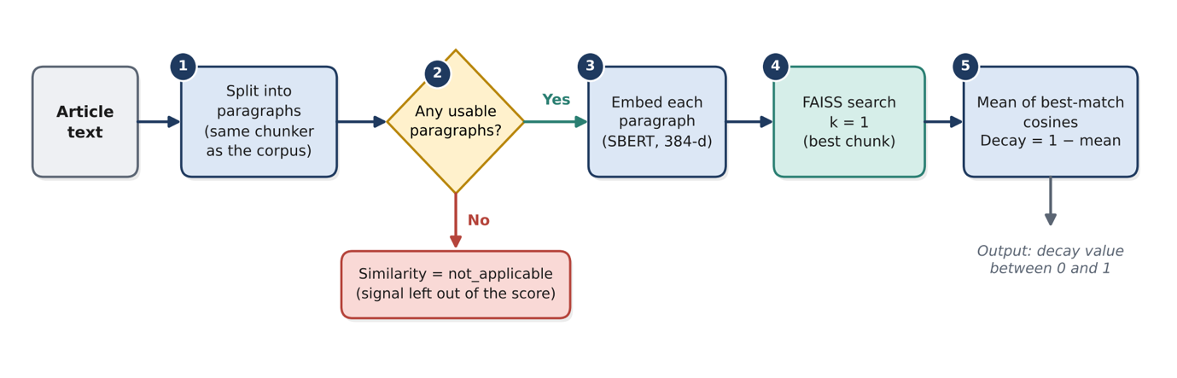
Figure 5.1 illustrates the computation of semantic similarity. The article is split into paragraphs using the same function that was used to divide the corpus, resulting in identical chunking on both sides. Every paragraph is matched to the closest corpus chunk, and the article's similarity is calculated by averaging these best matches. Decay is equal to 1 minus that similarity.

Figure 5.1:Flow chart of the semantic similarity signal
Terminology drift
Figure 5.2 shows the terminology check. The glossary holds five pairs of an outdated term and its current name, for example "Azure AD" and "Microsoft Entra ID". Terms are matched as whole words and the longest term is tried first, so "Azure AD PowerShell" is not also counted as "Azure AD". A match is not counted when its sentence is explaining the change.

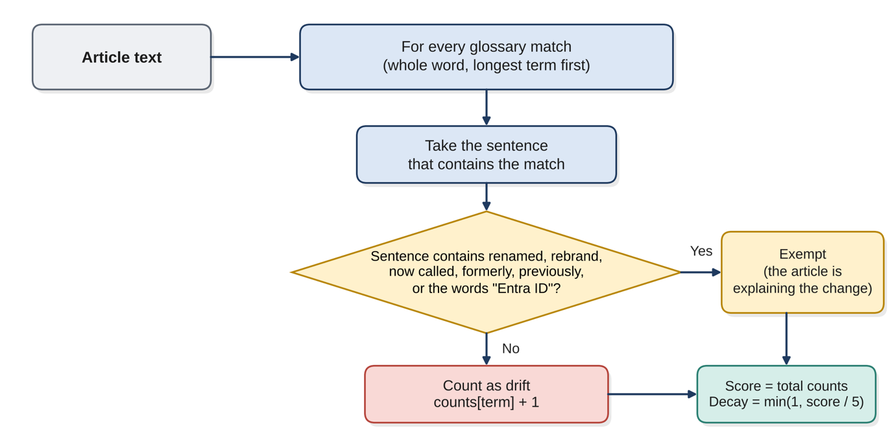

Figure 5.2:Flow chart of the terminology drift signal
Broken links
Figure 5.3 shows how each link is judged. A link that answers with any 2xx status is healthy. A 403 or 429 answer usually means that the site is refusing automated requests, and a timeout usually means that the server was slow. Neither says anything about whether the page still exists, so these links are set aside as inconclusive. Only the remaining links are counted.
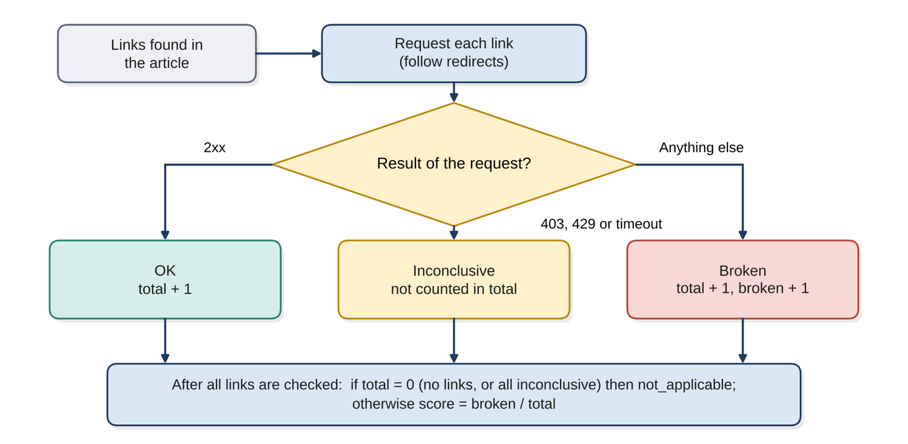

Figure 5.3:Flow chart of the broken links signal

Temporal metadata
Figure 5.4 shows how the article date is found. First it will attempt to extract a date from the structure of the document. Next, if no date was extracted from the structure, it will look for a date in a Meta tag. Finally, it will search all labelled dates within the viewable text. If none are found; it will simply report that it has returned a "date_unknown" and will make no other attempts to guess at the date. Any articles less than 12 months old receive an age score of 0. For every additional month, 1 is added to this number.
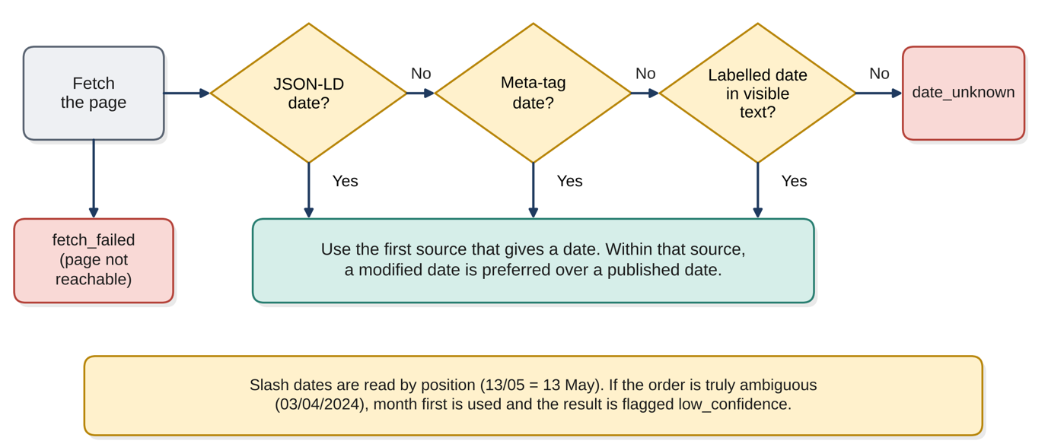

Figure 5.4:Flow chart of the date extraction chain used by the temporal metadata signal

Deprecated technology
The deprecated technology check is a short rule-based search and is given in Listing 5.1 as pseudocode. It looks for four retired or deprecated technologies. "Basic Authentication" is only retired in some settings, so a match counts only when a word such as Exchange, legacy or protocol appears in the same sentence.

Listing 5.1:Pseudocode of the deprecated technology signal

FOR each deprecated name found in the text (whole word, longest first):
technology = the standard name for this match
IF technology only counts in some contexts (Basic Authentication):
IF the sentence contains none of: Exchange, legacy, protocol,
deprecated, retired, retirement:
SKIP this match
count[technology] = count[technology] + 1
score = sum of all counts
decay = min(1, score / 3)

Combining the signals
Listing 5.2 gives the pseudocode for the final step. First each signal is converted to a decay value from 0 to 1 (the most decayed being 1). All signals that returned "not_applicable" are discarded; their total weight is then distributed evenly among all remaining signals.
Listing 5.2:Pseudocode of the score aggregation

active = the signals whose result is not "not_applicable"
IF active is empty:
score = none
ELSE:
FOR each signal s in active:
weight[s] = 0.2 / (0.2 x number of active signals)
decay[s] = the signal result turned into a value from 0 to 1
score = 100 x sum of ( weight[s] x decay[s] )

Table 5.2:Summary of the five decay signals
Signal | What is compared | Raw result | Decay value (0 to 1) | not_applicable when
Semantic similarity | Article paragraphs against 123,193 corpus chunks | Mean best-match cosine similarity | 1 minus similarity | No usable paragraphs
Terminology drift | Article text against a glossary of 5 outdated terms | Number of outdated terms counted | min(1, count / 5) | Never (zero means no decay)
Broken links | Final status of each link in the article | Broken links divided by links checked | The ratio itself | No links, or every link inconclusive
Deprecated technology | Article text against 4 deprecated technologies | Number of mentions counted | min(1, count / 3) | Never (zero means no decay)
Temporal metadata | Article date against today | Months beyond the 12-month window | min(1, months / 36) | Date unknown or page not fetched

5.2.2. Block Diagram Series
Figure 5.5 illustrates the complete system architecture in block diagram form. The input check decides whether the user supplied a URL or pasted text. A URL goes down the left path, where the page is fetched and its text, date and links are extracted. Pasted text goes down the right path, where there is no page to read a date from, so the temporal signal is left out automatically. Both paths then feed the same five signals.
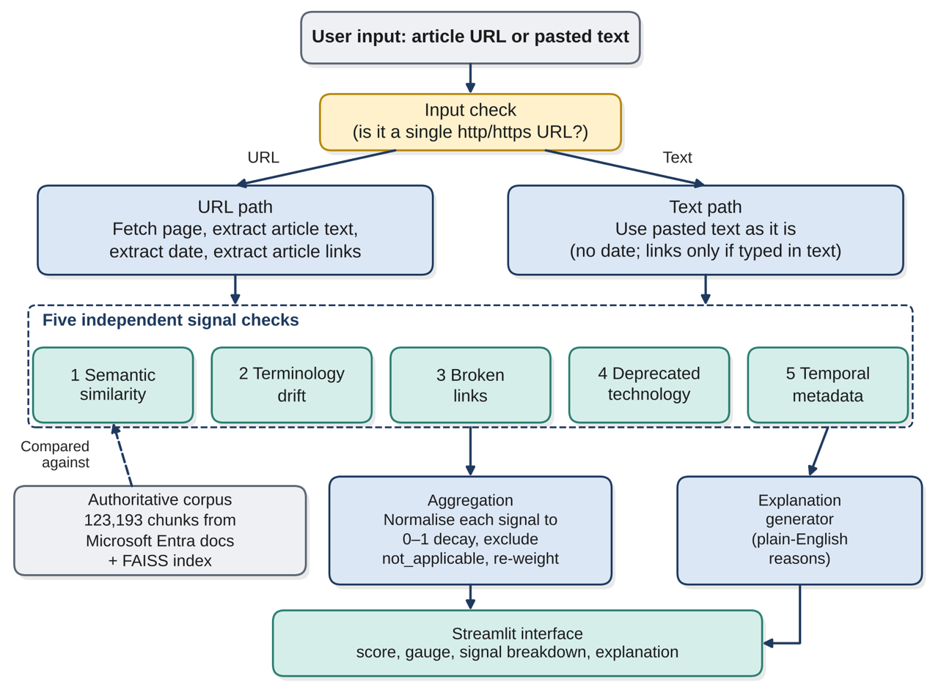

Figure 5.5:Block diagram of the Multi-Signal Knowledge Decay Framework

Figure 5.6 shows how the authoritative corpus was prepared. This is done once, before any article is checked. The embeddings are saved to disk so that they do not have to be recalculated each time the application starts, and the FAISS index is rebuilt in memory from them at start-up.
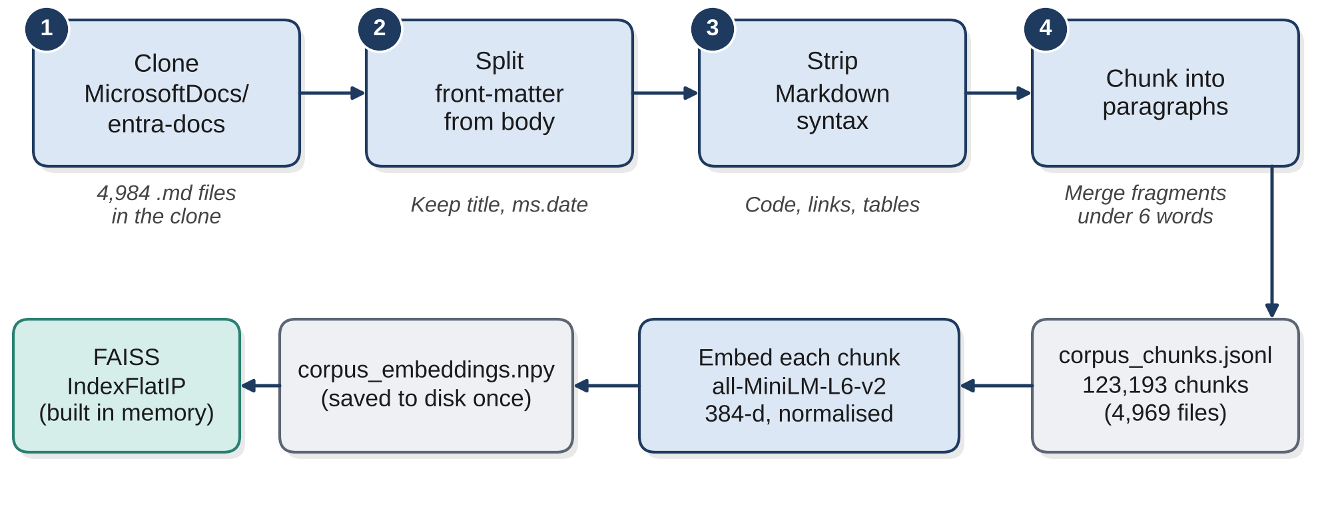

Figure 5.6:Block diagram of the corpus preparation steps
Table 5.3 links the functional and non-functional requirements of Chapter 4 to the code modules that satisfy them, so that each requirement can be traced to a part of the prototype.
Table 5.3:Traceability of requirements to code modules
Requirement | Implemented by | Module
FR1 | Input check that separates a URL from pasted text; one text box in the interface | pipeline.py, app.py
FR2 | Removal of navigation, adverts and page clutter; selection of the main article block | extract_article_text.py
FR3, FR4 | Best-matching corpus chunk and source file for each paragraph; mean similarity | semantic_similarity.py
FR5 | Glossary check with whole-word matching | terminology_drift.py
FR6 | Link extraction from the article body and status checks | extract_article_text.py, broken_links.py
FR7 | List of deprecated technologies with context rule | deprecated_tech.py
FR8 | Date extraction and age scoring | extract_date.py, temporal_metadata.py
FR9 | Weighted combination with not_applicable handling | combine_signals.py
FR10, NFR3 | Plain-English explanation shown with the score | combine_signals.py, app.py
FR11, NFR5 | The pipeline code contains no step that writes the article to disk | pipeline.py and the signal modules
NFR4 | Failure values (fetch_failed, extraction_failed, blocked) and readable error messages | extract_article_text.py, app.py
NFR6 | One module per signal, each runnable and testable alone | All signal modules

5.2.3. Justification of Technologies
Two choices come directly from the design of this study: Sentence-BERT for the meaning of text (Reimers and Gurevych, 2019) and FAISS for searching the resulting vectors (Johnson et al., 2019). The choices below follow from them.

5.2.3.1. Programming language
Table 5.4:Programming language
Choice | Reason for choosing it | Alternatives not used
Python 3.12 | The sentence-embedding and vector-search libraries used here are published mainly for Python, and one language could then be used for the extraction, the signals and the interface. Version 3.12 was chosen over newer releases because it was known to work with the faiss-cpu package on Windows. | Java and JavaScript were not ruled out in principle, but they offer less direct support for the combination of SBERT and FAISS used in this study.

5.2.3.2. Libraries used
Table 5.5:Libraries used and the reason for each
Library | Used for | Why it was chosen
sentence-transformers (model all-MiniLM-L6-v2) | Turning corpus chunks and article paragraphs into 384-dimensional vectors | A compact, widely used SBERT model; the same model must be used on both sides of the comparison
faiss-cpu | Exact nearest-neighbour search (IndexFlatIP) over the corpus vectors | Matches the design chapters; a flat index gives exact results, so the search adds no approximation error
NumPy | Holding the saved embeddings and the search results | Required by the two libraries above
PyYAML | Reading the front-matter (title and ms.date) of each corpus file | Front-matter in the Microsoft files is written in YAML
Beautiful Soup 4 | Removing page clutter and finding the main article block and its links | Copes with untidy real-world HTML
truststore | Letting Python trust the operating system certificate store | Without it, HTTPS requests failed on the virtual machine (Section 5.3.7)
urllib, re, json, datetime, html.parser (Python standard library) | Fetching pages and links, pattern matching, reading JSON-LD, date handling and reading meta tags | Part of Python, so nothing extra to install and fewer things that can break
Streamlit | The single-page user interface | See Table 5.6
Plotly | The gauge that shows the score | Draws the gauge inside Streamlit with a few lines of code

5.2.3.3. Back-end and front-end frameworks
Table 5.6:Back-end and front-end choices
Layer | Choice | Reason
Front end | Streamlit page with a text box, a Submit button and result panels | The interface is written in Python, so no separate web code was needed. NFR2 asks only for a simple single-page interface.
Back end | The Python pipeline (pipeline.py) called directly by the Streamlit page | One application is easy to run and to explain. A separate web server such as Flask or Django with its own front end was not used because it would add code without adding any capability the study needs.
Data store | Two local files: corpus_chunks.jsonl and corpus_embeddings.npy | The corpus is read-only. Submitted articles are never saved (FR11), so no database is needed.

5.3. Significant Implementation Attempts
This section covers only the parts of the prototype that carry special logic introduced by this study. Fetching a web page or drawing a text box is not described, because nothing original is involved. Each part is shown with a code extract copied from the working program and with the evidence that it behaves as described.

5.3.1. Semantic Comparison Against the Authoritative Corpus
The authoritative source is the public MicrosoftDocs/entra-docs repository. After cleaning and chunking, it gave 123,193 paragraph-sized chunks. Every chunk keeps its title, its ms.date value and its source file. Figure 5.7 shows the counting step that confirmed the size of the cloned repository.
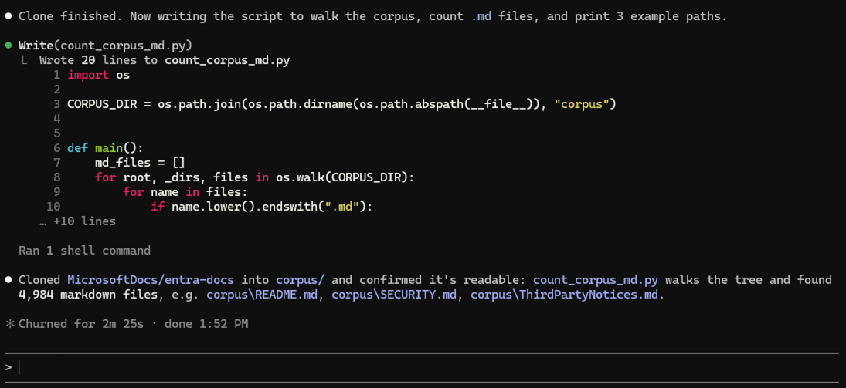

Figure 5.7:Terminal output confirming 4,984 markdown files in the cloned corpus
At start-up the saved vectors are loaded into an exact FAISS index. The vectors are normalised to unit length, so the inner product that the index calculates is the same as cosine similarity. For each article paragraph the index returns the single closest chunk, and Listing 5.3 shows this step. The mean of the best matches is the similarity of the article, so an article whose paragraphs have no close counterpart in current documentation receives a low similarity and therefore a high decay value.
Listing 5.3:Extract from semantic_similarity.py: matching each article paragraph to its closest corpus chunk

q = s["model"].encode(paragraphs, normalize_embeddings=True, show_progress_bar=False)
q = np.ascontiguousarray(q, dtype="float32")
sims, idx = s["index"].search(q, 1) # cosine (unit vectors), best match only
best, best_idx = sims[:, 0], idx[:, 0]

matches = [
{"paragraph": paragraphs[i][:80], "similarity": float(best[i]),
"source": s["chunks"][best_idx[i]]["source"]}
for i in range(len(paragraphs))
]
return {"similarity": float(best.mean()), "paragraphs": len(paragraphs),
"best_matches": matches}

The first version of this step used a NumPy matrix product instead of FAISS. This gave the same answer, but the design chapters had named FAISS as the search component, so the step was changed to match the design. To make sure that nothing else changed, the same three inputs were scored with the old and the new code. Table 5.8 shows that the two versions agree to within rounding error. Table 5.7 shows the earlier proof of concept, which confirmed that the search separates relevant text from unrelated text.
Table 5.7:Proof of concept for the similarity search
Query | Similarity | Reading
On-topic query about Microsoft Entra ID | 0.86 | Closely matched in the corpus
Unrelated control query (sourdough bread) | 0.28 | No meaningful match, as expected

Table 5.8: Equivalence check between the NumPy and FAISS versions
Check | Result
Inputs scored with both versions | Three (two article texts and one test sentence)
Largest difference in any similarity value | 3 × 10⁻⁷
Knowledge Decay Score of the InventiveHQ article | 21.7 before and 21.7 after

5.3.2 Context-Aware Terminology Drift
A simple search for old product names would punish the very articles that explain the rename. An article that says "Azure AD is now called Microsoft Entra ID" contains the old name, but it is helping the reader and should not be treated as outdated. Two exemption rules were therefore added. A match is not counted when its sentence contains a word such as renamed, rebrand, now called, formerly or previously, or when the same sentence names "Entra ID". Listing 5.4 shows the two patterns, and Listing 5.5 shows how they are applied to each match.

Listing 5.4:Extract from terminology_drift.py: the two exemption patterns
# An outdated term mentioned in the same sentence as one of these is being
# explained as outdated (e.g. "Azure AD was renamed to Microsoft Entra ID"),
# not used as current terminology, so that mention is not counted as drift.
_EXPLAINING_RE = re.compile(
r"(?<!\w)(?:renam(?:e|ed|ing)|rebrand(?:ed|ing)?|now\s+called|formerly|previously)(?!\w)",
re.IGNORECASE,
)

# A sentence that also names "Entra ID" alongside the outdated term is reliably
# contrasting old vs. new (e.g. "Azure AD ... now Entra ID"), not just reusing
# the old name, so it's exempted too even without one of the trigger words above.
_ENTRA_ID_RE = re.compile(r"(?<!\w)Entra\s+ID(?!\w)", re.IGNORECASE)

Listing 5.5:Extract from terminology_drift.py: counting a match or exempting it
counts = {}
exempted = 0
for m in _PATTERN.finditer(text):
sentence = _sentence_at(text, m.start())
if _EXPLAINING_RE.search(sentence) or _ENTRA_ID_RE.search(sentence):
exempted += 1
continue
canonical = _LOOKUP[m.group(1).lower()]
counts[canonical] = counts.get(canonical, 0) + 1)

The InventiveHQ guide discusses the move from Azure Active Directory to Entra ID, so it is a good test of these rules. Mentions inside sentences that explain the change were exempted, and 4 counted mentions remained. The explanation in Figure 5.12 shows the result. The exemption on the word "Entra ID" is a deliberate trade-off. The evaluation in Chapter 6 investigates whether this results in missed detections, as it can justify a sentence that continues to employ the outdated name as if it were current. A later run on a current Microsoft Learn page about Microsoft Entra Connect showed a limit of the glossary. The page was 0 months old and scored 22.0, but the terminology signal reached its maximum of 1.00. Seven mentions of “Azure AD” were counted, and all of them sit inside the names of retired products, such as “Azure AD Connect V1” and “Azure AD Sync”. The check cannot yet tell a historical product name from an outdated use of the old brand, so this is a false positive. Chapter 6 measures how often it occurs.

5.3.3. Handling Inconclusive Evidence
Many websites refuse requests from programs, and some answer too slowly. If a link checker classifies every refusal or delay (i.e., when it cannot obtain a response) as "broken", then many good pages will be classified as "dead" and will be penalized for another site's behavior. Therefore, this checker identifies three possible results: ok, inconclusive and broken. Listing 5.6 describes how the decision is made. Redirects are followed, so the status code returned by the last page visited after following redirects is used. All 2xx status codes are acceptable. If the checker has evaluated every hyperlink on a given article with a result of either inconclusive or if there are no hyperlinks on the article, the signal sent back is not_applicable rather than a score of 0. This is because "no check was done" is different from "all checks were passed.
Listing 5.6:Extract from broken_links.py: classifying one link
def _is_timeout(exc):
"""True if the error is a timeout (a slow server, not proof of a dead page)."""
if isinstance(exc, TimeoutError): # socket.timeout is the same class in Python 3.10+
return True
return isinstance(exc, urllib.error.URLError) and isinstance(exc.reason, TimeoutError)

def check_url(url, timeout=10):
"""Return (status, detail).
status is "ok" (final 2xx), "inconclusive" (403, 429 or a timeout) or
"broken" (anything else).
"""
req = urllib.request.Request(url, headers=_HEADERS)
try:
# urllib follows redirects, so the status is that of the final page.
with urllib.request.urlopen(req, timeout=timeout) as resp:
if 200 <= resp.status < 300:
return "ok", str(resp.status)
return "broken", str(resp.status)
except urllib.error.HTTPError as e:
code = str(e.code)
return ("inconclusive" if code in _INCONCLUSIVE_STATUSES else "broken"), code
except Exception as e:
if _is_timeout(e): # slow server: say nothing about whether the page exists
return "inconclusive", f"{type(e).__name__}: {e}"
return "broken", f"{type(e).__name__}: {e}" # DNS failure, SSL error, etc.

The same concept was used for the article page itself. If the article page returned a 403 or 429 status, the pipeline reported it as blocked but did not classify it as "dead". Therefore the text of the Lepide article could be inserted into the UI instead and then scored via the text path. Figure 5.8 represents an old version of one of the first test runs of this pipeline which represented a flaw (later removed) - there was a link that had been identified as broken when the checker returned a 202 status while 202 is actually a successful status. This checker was modified to include all statuses in the 2xx range.

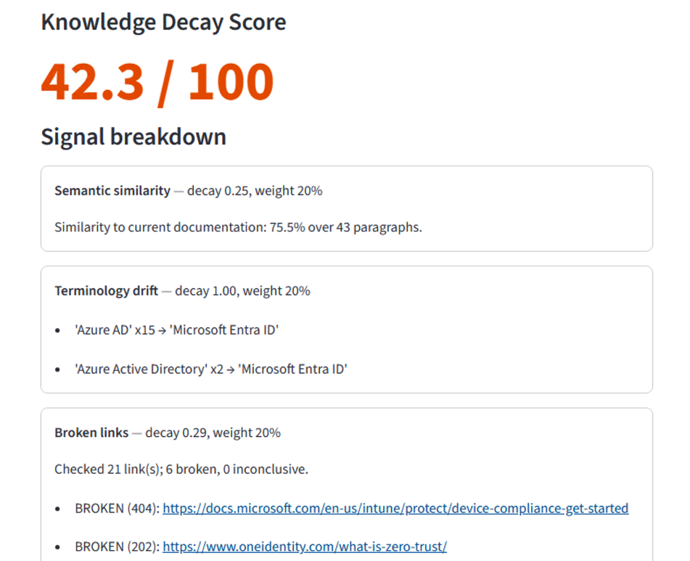

Figure 5.8:Early test run in which a 202 response was wrongly reported as a broken link

5.3.4. Date Extraction Chain
Web pages show their dates in many different ways, so no single rule is reliable. The extractor, shown in Listing 5.7, tries three sources in order of trust: JSON-LD structured data, then meta tags, then labelled dates in the visible text such as "Updated Jul 12, 2023". A modified date is preferred over a published date, because a page that was revised recently is better maintained than its publication date suggests. If none of the three sources gives a date the result is date_unknown, and the temporal signal is left out instead of guessing.

Listing 5.7:Extract from extract_date.py: the three-step fallback chain
# 1a) JSON-LD
ld = []
for body in p.jsonld:
try:
found = []
_walk_jsonld(json.loads(body), found)
ld += [(k, r, "json-ld") for k, r in found]
except ValueError:
continue
if hit := _pick(ld):
return {**hit, "method": "structured:json-ld"}

# 1b) Meta tags
metas = [(_META_KEYS[k], v, f"meta:{k}") for k, v in p.meta if k in _META_KEYS]
if hit := _pick(metas):
return {**hit, "method": "structured:meta"}

# 2) Labelled dates in visible text
text = " ".join(" ".join(p.text).split())
texts = []
for m in _TEXT_RE.finditer(text):
label = m.group(1).lower()
kind = "published" if label.startswith(("publ", "post")) else "modified"
texts.append((kind, m.group(2), f"text:{m.group(0)}"))
if hit := _pick(texts, parse_text_date):
return {**hit, "method": "text-pattern"}

# 3) Give up rather than guess
return {"date": UNKNOWN, "method": "none", "kind": None, "raw": None,
"source": None, "ambiguous_date_format": False}

Slash dates need extra care. A first number above 12 can only be a day, and a second number above 12 can only be a day. If both are 12 or less and they differ, as in 03/04/2024, the order cannot be known. The extractor then reads the date as month first, which is the convention of the corpus, and flags the result so that the interface can mark the temporal result as low confidence. Table 5.9 shows the extractor run on three real pages.
Table 5.9:Date extraction on real pages
Page | Date returned | Kind | Method
Microsoft Tech Community: Azure AD is Becoming Microsoft Entra ID | 2023-07-12 | Modified | Text pattern ("Updated Jul 12, 2023")
InventiveHQ: Azure AD to Entra ID guide | 2026-02-14 | Modified | JSON-LD
example.com (a page with no date) | date_unknown | None | None

The meta-tag step did not fire on any live page in these tests, so it was checked only on a short synthetic snippet. This is a limit of the present evidence and not of the code. The date check on pages with meta-tag dates is part of the testing in Chapter 6.

5.3.5. Score Aggregation with Weight Redistribution and Explanation
Each signal result has a different scale, so each is first turned into a decay value between 0 and 1. The weights start at 20 percent each. When a signal is not_applicable it is removed and its weight is shared equally among the others, so that a missing date does not make an article look fresher than it is. Listing 5.8 shows this step. Figure 5.9(a) shows the effect when the temporal signal is excluded, which always happens on the pasted-text path. Figure 5.9(b) works through the real InventiveHQ result. Terminology drift (4 counted mentions, decay 0.80) contributes 16.0 points, and semantic similarity (about 71 percent) contributes about 5.7 points. The other three signals contribute nothing, which gives the reported score of 21.7.

Listing 5.8:Extract from combine_signals.py: removing not_applicable signals and re-weighting

excluded = [n for n in SIGNALS if _is_na(results[n])]
active = [n for n in SIGNALS if n not in excluded]
if not active:
return {"score": None, "signal_decay": {}, "effective_weights": {},
"excluded": excluded, "low_confidence": []}

total_weight = sum(weights[n] for n in active)
effective = {n: weights[n] / total_weight for n in active}
decay = {n: signal_decay(n, results[n]) for n in active}
score = 100 * sum(effective[n] * decay[n] for n in active)

low_conf = [n for n in active
if isinstance(results[n], dict) and results[n].get("low_confidence")]
return {"score": round(score, 1), "signal_decay": decay,
"effective_weights": effective, "excluded": excluded,
"low_confidence": low_conf}

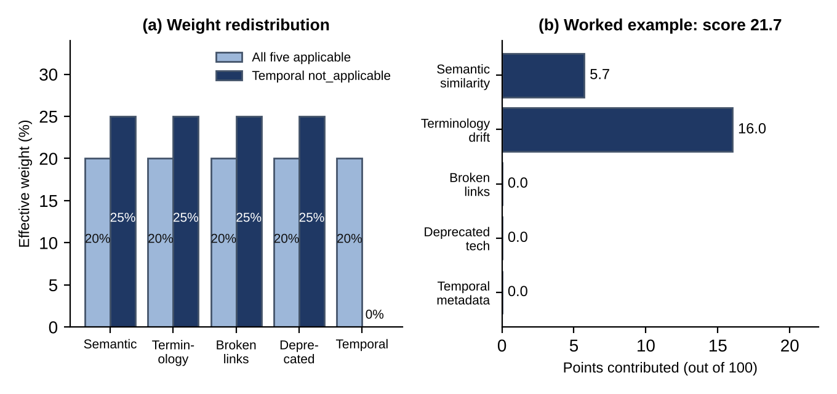

Figure 5.9:Weight redistribution when a signal is excluded (a) and the contribution of each signal to the InventiveHQ score (b)

The explanation generator turns the same numbers into sentences. A signal is only mentioned when its decay value is at least 0.2, so the explanation lists the reasons that mattered and is not padded with signals that found nothing. For the InventiveHQ article it produced two sentences: "This article's similarity to current documentation is 71%." and "This article uses outdated terminology: 'Azure AD' (now 'Microsoft Entra ID')." (Figure 5.12). Table 5.10 lists every number in the aggregation that was set by judgement. All are provisional starting points and will be tuned with labelled data in Chapter 6.
Table 5.10:Provisional parameters of the prototype
Parameter | Value | Meaning
Signal weights | 20% each | Equal weighting as a neutral starting point
Terminology cap | 5 terms | This many outdated terms gives full decay
Deprecated technology cap | 3 mentions | This many mentions gives full decay
Freshness window | 12 months | No temporal decay inside this age
Temporal cap | 36 months | Months beyond the window that give full decay
Explanation threshold | 0.2 | Minimum decay for a signal to be mentioned
Minimum article text | 500 characters | Shorter extractions are treated as extraction_failed
Score bands | 30 and 60 | Green below 30, amber 30 to 60, red above 60
Time-outs | 10 s per link, 15 s per page | Limits waiting on slow sites

5.3.6. User Interface
The interface is one page with a single text box. If the input is one web address the URL path is used, and otherwise the input is treated as pasted article text (FR1). Figure 5.10 shows a URL submitted for the Quest conditional access article. The score is shown in large type and coloured by band, and the gauge in Figure 5.11 repeats the same three bands.

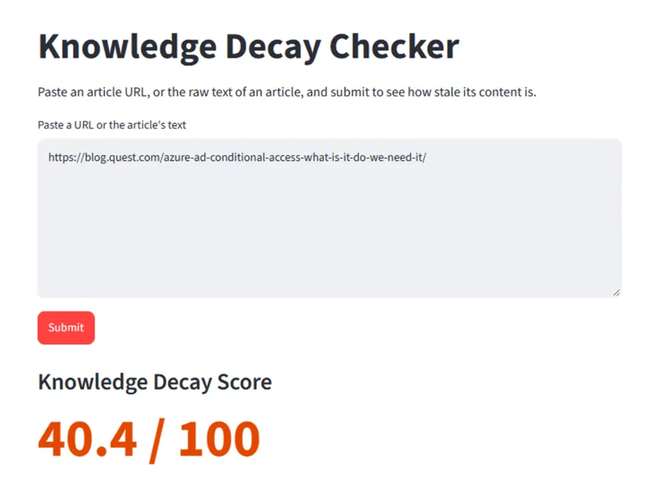

Figure 5.10:The interface after a URL has been submitted
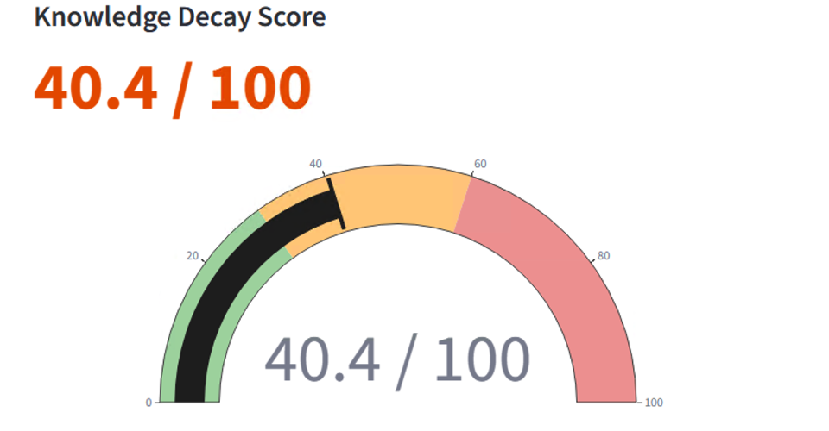
Figure 5.11:Score and gauge for the same article (40.4 out of 100)
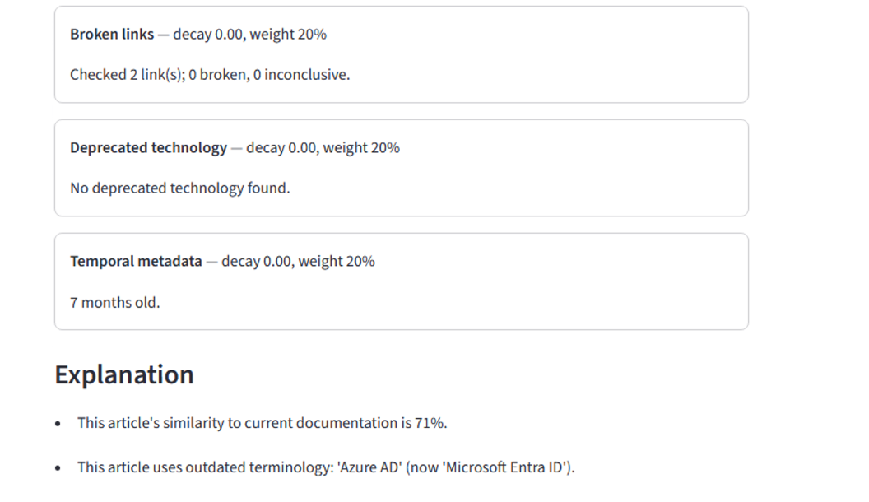
Below the gauge each signal has its own panel with weight and evidence behind it (figure 5.11) the bottom half of the screen in figure 5.12 show the panels for the inventivehq guide along with an explanation underneath. Signals that were previously excluded are shown as "not applicable" so users can see what caused the change to their respective weights. At the opposite extreme is a well-maintained web site from Ravenswood Technology on Entra ID score, which, at 5.3, will be displayed as having very little decay (figure 5.13).

Figure 5.12:Lower signal panels and explanation for the InventiveHQ article

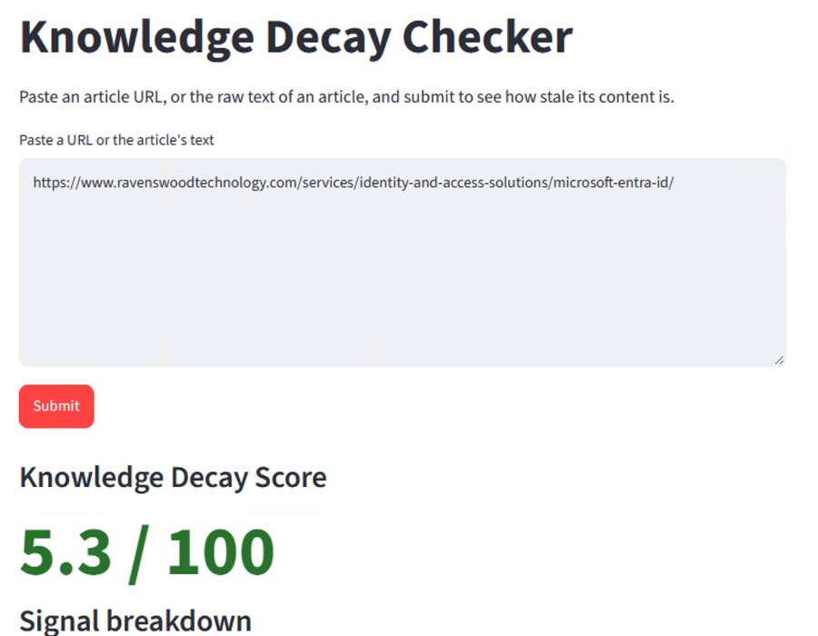

Figure 5.13:A low-decay result (5.3 out of 100) for a maintained Entra ID page

When the pipeline cannot produce a score it shows a plain message instead of a failure, as required by NFR4. Table 5.11 lists the messages.
Table 5.11:Messages shown when the pipeline cannot return a score
Internal value | Message shown to the user
fetch_failed | Could not fetch that URL.
extraction_failed | Fetched the page, but couldn't find article text on it.
blocked | That site blocked the request (403/429), likely bot-blocking rather than a dead page.
empty_text | No text to analyze.

5.3.7. Problems Met and How They Were Resolved
Several design decisions above came from things that went wrong during development. Table 5.12 lists the main ones. Figure 5.14 shows the first of them as it appeared in the interface.
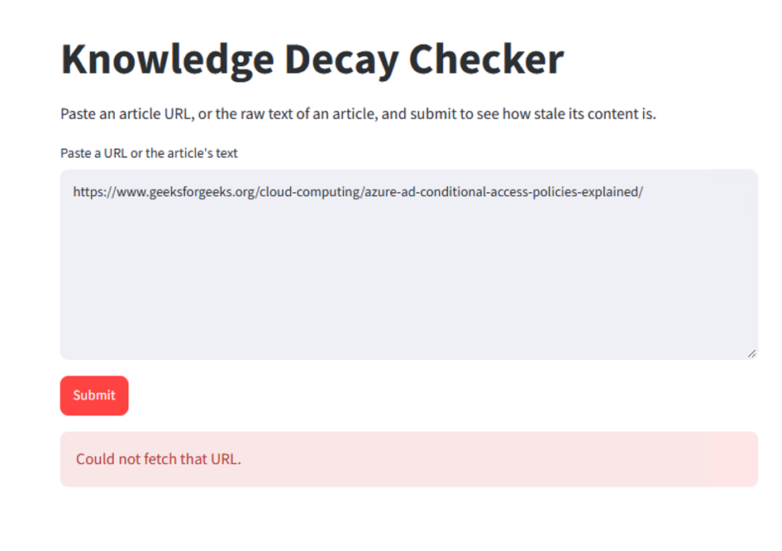

Figure 5.14:Early failure on a GeeksforGeeks page caused by certificate checking on the virtual machine

Table 5.12:Main problems found during development
Problem | Cause | Resolution | Where it shows
Some URLs returned "Could not fetch that URL" | The network on the virtual machine re-signs HTTPS traffic with its own certificate, which Python did not trust | truststore makes Python use the operating system certificate store | Figure 5.14; the same article later scored 28.2
A healthy link was reported broken | Status 202 was treated as an error | All 2xx statuses are accepted | Figure 5.8
Sites that block programs gave false broken links | 403 and 429 answers were counted as dead pages | Inconclusive state, blocked page state and a paste-text path | Section 5.3.3
Explanatory sentences were counted as outdated | Plain term matching ignores context | Exemption patterns for rename wording and "Entra ID" | Section 5.3.2
"Basic Authentication" matched unrelated text | The phrase has many harmless uses | Counts only with a context word in the same sentence | Listing 5.1
Wrong part of a page extracted | Pages without a clear article block | Extractions under 500 characters are rejected; the limit is provisional | Table 5.10
Building the corpus index was slow | Embedding 123,193 chunks on a CPU-only virtual machine took about 18 minutes | The corpus is embedded once and saved to disk; each article check then only embeds its own paragraphs | Section 5.2.2
Design said FAISS, code used NumPy | The first version used a matrix product | Search switched to FAISS and checked for equivalence | Table 5.8
A working link timed out | A slow server did not reply in time | Timeouts are now inconclusive, like 403 and 429 | Section 5.3.3

5.3.8. Results on Real Articles
To finish this chapter, the complete prototype was run on four real third-party articles about Entra ID. Table 5.13 and Figure 5.15 show the scores. These runs show that the prototype works from end to end and that its scores separate a maintained page from articles that use old terminology. They are not an evaluation. There were no ground-truth labels employed, and the formal accuracy measures are detailed in Chapter 6.

Table 5.13:Knowledge Decay Scores for four real articles
Article | Score | Main reasons visible in the output
Ravenswood Technology: Entra ID services page | 5.3 | Semantic decay of 0.27 only; every other signal found nothing
InventiveHQ: Azure AD to Entra ID guide | 21.7 | Four counted uses of the old name "Azure AD"; similarity 71%
GeeksforGeeks: Azure AD Conditional Access policies | 28.2 | Mixed terminology; semantic decay 0.38
Quest blog: Azure AD Conditional Access | 40.4 | Heavy use of old terminology; an older article with some broken links

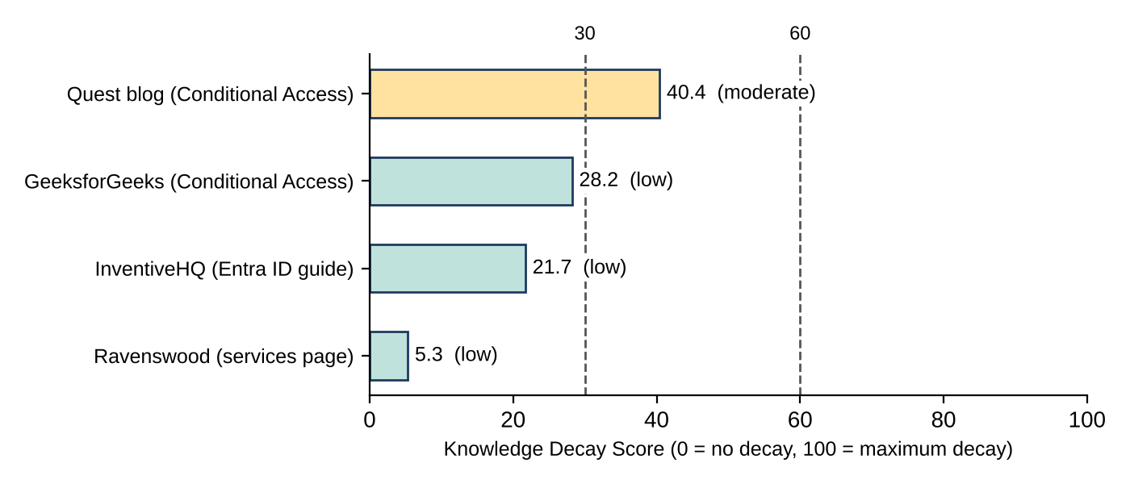

Figure 5.15:Knowledge Decay Scores for the four real articles, with the provisional bands at 30 and 60

5.4. Chapter Summary
This chapter described how the framework of Chapter 4 was built as a working prototype. Section 5.2 presented the build stages, the logic of the five signals as flow charts and pseudocode, the block diagrams of the framework and of the corpus preparation, and the justification of the language, libraries and interface framework. Section 5.3 then explained the parts that carry the original work of this study. These are the exact semantic search over 123,193 corpus chunks, the terminology check that understands when an article is explaining a rename, the separation of broken, inconclusive and healthy links, the three-step date extraction, and the re-weighting that keeps a missing signal from distorting the score. Each was shown with real code and with output from the running system.
The prototype has limits that Chapter 6 must examine. The glossary of outdated terms has only five entries and the list of deprecated technologies has four, both compiled by hand. Every threshold in Table 5.10 is a provisional value, and the corpus covers a single Microsoft repository. The "Entra ID" exemption may excuse a few sentences that it should not. The glossary check also counts the old name when it appears inside the name of a retired product.Chapter 6 tests these points with a labelled dataset, precision, recall and F1 measures, and an ablation study that removes one signal at a time.

Testing & Evaluation

Chapter Overview
This chapter reports the testing and evaluation of the prototype that was detailed in Chapter 5. The test plan and the ten primary test cases are outlined in Section 6.2. These include the functional requirements of Chapter 4 as well as the non-functional attributes of accuracy, performance, and scalability. The evaluation process, including the creation of the labeled dataset, is covered in Section 6.3. Section 6.4 reviews the testing and evaluation strategies listed for this module, explains which of them suit this research, and reports the results of those that were used. The chapter ends with a summary of what the evidence shows and where it is weak. The labelled dataset and the remaining test cases are given in the appendices.

6.2. Test Plan and Test Cases
The test strategy follows from what the prototype is. It is a classifier: it turns an article into a score, and the score is used to say that the article is outdated or current. A classifier is judged by comparing its answers with answers that are already known, so the main test is a labelled dataset of real articles. Tests are conducted independently for speed, size restrictions, and each of Chapter 4's specific requirements. The 10 primary test cases are listed in Table 6.1 along with the requirements that each one verifies. Most of them use the same batch run of 44 articles, so the plan needed one batch run and one separate test of the link checker.
Table 6.1:The ten main test cases (Req. = requirement)
ID | Req. | What was tested | Result | Outcome
TC1 | FR1 | Submit articles by web address and as pasted text | 34 articles were scored from their web address. 10 more were scored from pasted text after their addresses failed to give readable text | Pass
TC2 | FR2, NFR4 | Submit addresses whose pages cannot be read | 10 of 44 addresses returned extraction_failed with no score. The other 34 gave article text, so extraction worked for 77% | NFR4 pass; FR2 partial
TC3 | FR3, FR4 | Compare every article with the corpus | All 44 articles received a similarity value, between 0.55 and 0.77 | Pass
TC4 | FR5 | Check that old product names raise the terminology result | The maximum terminology decay (1.0) occurred in 18 of 20 Outdated and 5 of 24 Current articles | Pass
TC5 | FR6 | Check how each type of link outcome is classified (Section 6.2.2) | All 8 link cases and both combined checks gave the expected status | Pass
TC6 | FR7 | Check the list of deprecated technologies | The signal fired on 1 of 44 articles (A15, a Current article about retired modules). It did not fire on the one article labelled Deprecated tech | Not evaluable
TC7 | FR8 | Find the date of each page | 28 of the 34 pages fetched by web address gave a date: 23 from structured data, 3 from visible text and 2 from meta tags | Pass
TC8 | FR9 | Recompute every score from its stored signal values | Stored and recomputed scores agreed for all 44 articles (to the one decimal place stored) | Pass
TC9 | NFR1 | Time each article from submission to score | Median 7.1 s for web addresses and 2.0 s for pasted text; slowest 50.9 s | Pass, with a note
TC10 | NFR6, FR9 | Leave out signals that are not_applicable, and leave out one signal at a time | Temporal was left out for 16 articles and links for 5, and their scores recomputed correctly. Each signal could also be removed alone (Section 6.4.3) | Pass

Five requirements are not covered by these cases. FR11 and NFR5 ask that submitted content is not stored, and Chapter 5 shows that the code has no step that writes an article to disk. They were therefore checked by reading the code and not by a separate test. The batch script does save article text for the evaluation, but only in an evaluation folder and not in the live interface. NFR2 asks for a usable interface. Testing that fairly needs participants, which this study does not use (Chapter 3), so only the single-page design shown in Chapter 5 can be reported. FR10 and NFR3 require that every score be accompanied by a reason in plain language. These were only examined on the four demonstration articles in Chapter 5 (Section 5.3.8 and Figure 5.12), not the 44 articles, because the batch run does not preserve the explanatory text.

6.2.1. Non-Functional Testing

6.2.1.1. Accuracy
Accuracy is the most important quality of a detector, so it received the main test. The 44 labelled articles were scored with the prototype, and "Outdated" was treated as the positive class. An article was predicted Outdated when its score was 30 or more, which is the border between the green and amber bands. This value was set in Chapter 5 before any labelled data was available and was not changed afterwards. The performance indicators are precision, recall, F1 and the area under the ROC curve (AUC). No pass mark was fixed in advance. Instead, the evaluation compares the combined score with chance and with each single signal, which is the comparison that Chapter 3 states as the research expectation.
Figure 6.1 shows the result. The prototype found 16 of the 20 Outdated articles and wrongly flagged 4 of the 24 Current articles. Table 6.2 gives the measures that follow from these counts, where TP is an Outdated article found, FP a Current article wrongly flagged, FN an Outdated article missed and TN a Current article correctly passed. Each has a 95% interval, which shows how far the value could move on a different sample of articles. With 44 articles the intervals are wide, so the figures are best read as "around 80%" and not as exact values
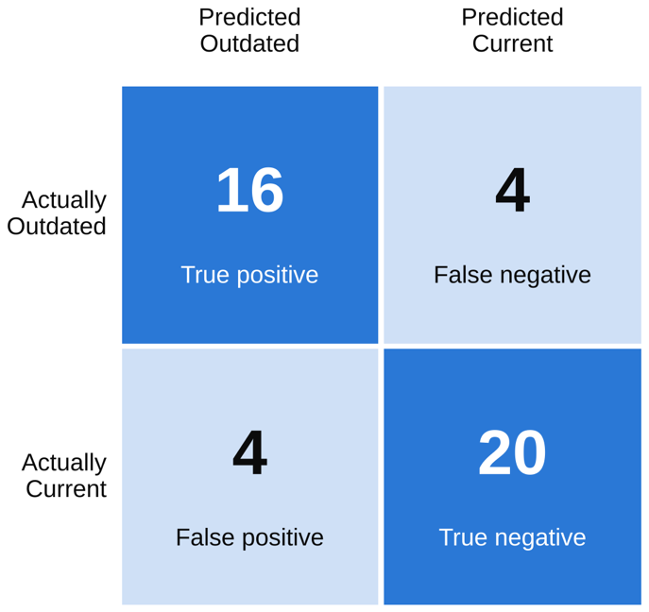

Figure 6.1:Confusion matrix at the threshold of 30

Table 6.2:Accuracy measures at the threshold of 30 with 95% intervals
Measure | Calculation | Value | 95% interval | How the interval was found
Precision | TP ÷ (TP + FP) = 16 ÷ 20 | 0.80 | 0.58 to 0.92 | Wilson interval
Recall | TP ÷ (TP + FN) = 16 ÷ 20 | 0.80 | 0.58 to 0.92 | Wilson interval
Specificity | TN ÷ (TN + FP) = 20 ÷ 24 | 0.83 | 0.64 to 0.93 | Wilson interval
Accuracy | (TP + TN) ÷ all articles = 36 ÷ 44 | 0.82 | 0.68 to 0.90 | Wilson interval
F1 | 2 × P × R ÷ (P + R) = 2 × 0.80 × 0.80 ÷ 1.60 | 0.80 | 0.64 to 0.92 | Bootstrap, 10,000 resamples
AUC | Area under the ROC curve (Section 6.4.4) | 0.887 | 0.77 to 0.98 | Bootstrap, 10,000 resamples

6.2.1.2. Performance
NFR1 asks for a score "within a reasonable interactive time frame" but gives no number. The time taken for each article was therefore recorded in the batch run, and Table 6.3 summarises it. Pasted text is faster because there is no page to fetch, and the pasted articles had fewer links that could be checked (3.1 on average against 13.9 for web addresses). For web addresses, the time grew with the number of links in the article (Spearman correlation 0.83, p < 0.001, n = 34). The slowest article, A32, also had the most links in the dataset (78). This suggests that checking links is the main cost, although the time spent on links was not measured separately. 20 of the 34 web addresses and 8 of the 10 pasted texts were scored in 10 seconds or less. A wait of this size is acceptable for a person checking one article, but not for checking many articles one after another.
Table 6.3:Time per article in the batch run
Input route | Articles | Mean (s) | Median (s) | Fastest (s) | Slowest (s)
Web address | 34 | 11.1 | 7.1 | 1.5 | 50.9
Pasted text | 10 | 4.3 | 2.0 | 1.1 | 13.1
All articles | 44 | 9.6 | 6.3 | 1.1 | 50.9

6.2.1.3. Scalability
The length of the article and the size of the corpus were the two factors used to evaluate scalability. Table 6.4 gives the measured figures. The corpus of 4,969 files produced 123,193 chunks, and embedding them took about 18 minutes on the CPU of the virtual machine. This is a one-off cost, because the embeddings are saved and loaded at start-up. The exact search compares each paragraph with every chunk, so its cost grows in proportion to the number of chunks. The memory needed for the index is easy to work out. It is 123,193 chunks of 384 numbers of 4 bytes each, which is about 189 MB.
For article length, the longest article (A43, about 66,000 characters) took 13.1 seconds when pasted as text, and the median article had about 7,900 characters. Length therefore has a small effect compared with the number of links. A corpus ten times larger would need about three hours of embedding and about 1.9 GB of memory, which would still fit on the 16 GiB machine, but this was calculated and not tested. A corpus much larger than that would need an approximate index, and this is listed as future work in Chapter 7. No test was run with more than one corpus, or with several users at the same time.
Table 6.4:Measured and calculated scale figures
Measure | Value | Source
Markdown files used from the corpus | 4,969 | Counted
Chunks in the index | 123,193 | Counted
One-off embedding time | About 18 minutes (CPU only) | Measured
Index size in memory | About 189 MB (123,193 × 384 × 4 bytes) | Calculated
Longest article processed | About 66,000 characters in 13.1 s | Measured
Corpus ten times larger | About 3 hours of embedding and 1.9 GB | Calculated, not tested

6.2.2. Functional Testing
Functional testing checks each requirement of Tables 4.4 and 4.5 against the behaviour of the prototype. Table 6.1 lists the cases and results. Most of them are checked through the batch run, because it exercises the same pipeline as the interface. The link checker needed a separate test, because its result depends on how real websites behave, and this changes from day to day. A small test server was used instead. It answers with each type of outcome on request, and Listing 6.1 shows the cases. Chapter 5 sets the rules: a 2xx answer is healthy, 403 and 429 answers and timeouts are inconclusive, and everything else is broken. The score is the number of broken links divided by the number of conclusive links (links that are either healthy or broken). Inconclusive links are left out. When every link is inconclusive, the signal is not_applicable.
Listing 6.1:The link outcome cases used in the link checker test (link_status_test.py)
cases = [ # (name, address, status the checker should return)
("200 OK", f"http://127.0.0.1:{port}/ok", "ok"),
("404 Not Found", f"http://127.0.0.1:{port}/nf", "broken"),
("403 Forbidden", f"http://127.0.0.1:{port}/forbid", "inconclusive"),
("429 Too Many Requests", f"http://127.0.0.1:{port}/many", "inconclusive"),
("Slow reply (timeout)", f"http://127.0.0.1:{port}/slow", "inconclusive"),
("No reply (timeout)", f"http://127.0.0.1:{hp}/x", "inconclusive"),
("Connection refused", f"http://127.0.0.1:{closed}/x", "broken"),
("DNS failure", "http://no-such-host.invalid/x", "broken"),
]
for name, url, expected in cases:
got, detail = check_url(url, timeout=3) # from broken_links.py
print(name, expected, got, "PASS" if got == expected else "FAIL")

All eight cases returned the expected status. When the eight links were checked together, 3 were broken out of 4 conclusive links, so the score was 0.75, and the 4 inconclusive links were left out. When only the two timeout links were submitted, the result was not_applicable. The test was run on the Windows development computer. On Windows a refused connection to a closed local port takes about two seconds to fail, so the test timeout was set to three seconds. The same rules were used in the batch run. Broken links were found in 9 of the 44 articles, and 5 articles had at least one inconclusive link.
The other functional cases were read from the batch results. For input (TC1 and TC2), 34 of the 44 addresses gave article text. The other 10 returned extraction_failed and no score, which is the clear error that NFR4 asks for, but it means that FR2 was only partly met. For dates (TC7), 28 of the 34 pages gave a date: 23 were retrieved from structured data, 3 from visible text and 2 from meta tags. The meta-tag route had not fired on a live page when Chapter 5 was written (Section 5.3.4), so these two pages close that gap. For scores (TC8), each score was recalculated using an average of the five individual signal values (all with equal weight); any individual signal which indicated "not applicable" was ignored. All 44 scores matched to the one decimal place that is stored.

6.3. Testing and Evaluation Workflow
The workflow is shown in Figure 6.2. The evaluation consists of six steps, each producing a file or figure that can be checked. Steps 2 through 4 are performed by a single script, batch_eval.py, allowing the entire evaluation to be repeated with two commands and producing the same results for the same dataset.
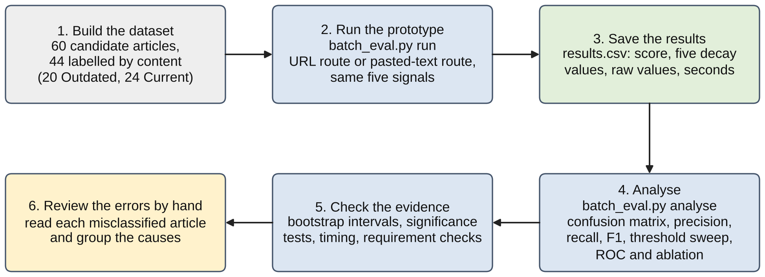

Figure 6.2:Workflow of the testing and evaluation

6.3.1. Building the Dataset
The prototype will compare third-party articles to those written by Microsoft. Therefore, in addition to Microsoft documentation, the dataset has to have third party articles. Fifty candidate articles were found through a general internet search of blogs and vendors writing about Entra ID and formerly known as Azure AD. Articles labeled for 32 topics included Conditional Access, Guest Users, PowerShell Modules, Hybrid Join etc., but many of these labels were very similar. Six candidates were deliberately left out of the evaluation. Five of them (A01 to A05) are the articles that were already run through the prototype while it was being built and demonstrated in Chapter 5, so they were kept apart as development examples and not used as test data. The sixth (A49) is a blog listing page and not a single article. That left 44 labelled articles. All forty four articles were reviewed on 16 & 17 Oct. 2026. As articles were based upon a search rather than randomly selected, the results represent the sample of search articles and may or may not be representative of all corporate knowledge bases.
The author labelled every article by reading its content. The date was deliberately not used for the label, because the temporal signal reads the date, and a label based on it would make the test circular. An article was labelled Outdated when it used a superseded product name as if it were current, when its steps or screens no longer matched the product, or when it relied on a deprecated technology. Every other article was labelled Current. Each label has a reason category, a short note and a confidence level (26 High, 17 Medium and 1 Low). Table 6.5 gives the composition.
Table 6.5:Composition of the labelled dataset
Label and reason category | Articles | Meaning
Outdated: Terminology | 12 | Uses a superseded name, such as Azure AD, as if it were current
Outdated: Steps changed | 7 | Describes screens or settings that have since changed
Outdated: Deprecated tech | 1 | Relies on a technology that has been retired (A26)
Current | 24 | Content still matches the product
Total | 44 | 20 Outdated and 24 Current

Two weaknesses follow from this design. First, one person labelled the articles, so no agreement between raters could be measured. The dataset has a column for a second rater, but it was not used. Second, 12 of the 20 Outdated labels are due to old terminology, which is the very thing the terminology signal looks for. The results for that signal are therefore partly built into the sample, and this is considered again in Section 6.4.3. Chapter 3 also expected some synthetic decay cases to be added. None were added, and the dataset contains only real articles.

6.3.2. Running and Analysing
Of the 44 addresses, 34 were scored directly by the extractor. For the remaining 10, the pages could not be read, so the article text was copied directly from the browser into text files without making any changes. Then, using the same pipeline's pasted-text option, these texts were scored. The batch results record which route was used for each article, allowing the two groups to be reported separately. Listing 6.2 explains the method for calculating counts and evaluation metrics, whereas Listing 6.3 illustrates how a score is recomputed from the stored signal values. In Section 6.4.3, the latter function is used to examine the effect of excluding individual signals from the score calculation.
Listing 6.2:Counting the outcomes and calculating the measures (batch_eval.py)

def confusion(pairs, thr):
"""pairs = [(is_outdated, score)]; predicted Outdated if score >= thr."""
tp = sum(1 for y, s in pairs if y and s >= thr)
fp = sum(1 for y, s in pairs if not y and s >= thr)
fn = sum(1 for y, s in pairs if y and s < thr)
tn = sum(1 for y, s in pairs if not y and s < thr)
return tp, fp, fn, tn

def metrics(tp, fp, fn, tn):
prec = tp / (tp + fp) if tp + fp else 0.0
rec = tp / (tp + fn) if tp + fn else 0.0
f1 = 2 * prec * rec / (prec + rec) if prec + rec else 0.0
spec = tn / (tn + fp) if tn + fp else 0.0
acc = (tp + tn) / (tp + fp + fn + tn)
return {"precision": prec, "recall": rec, "f1": f1,
"specificity": spec, "accuracy": acc}

Listing 6.3:Recomputing a score with one signal left out or used alone (batch_eval.py)
def rescore(row, drop=None, only=None):
"""Recompute the score from stored decays (equal weights)."""
active = []
for s in SIGNALS:
d = _f(row.get(f"decay_{SHORT[s]}"))
if d is None: # not_applicable: leave out, weight is shared
continue
if drop and s == drop: # ablation: leave this signal out
continue
if only and s != only: # single-signal test: keep only this one
continue
active.append(d)
return 100 * sum(active) / len(active) if active else None

6.4. Review of the Test Strategies Used
The module identifies seven strategies that could be suitable for a research project. Table 6.6 shows which strategies were selected and the reasons for choosing them. The selection was based on the nature of the data. The task has two known classes and one score, so measures of classification and tests that compare two groups fit it. Methods that depend on a panel of people do not fit a study without participants. Five of the seven were used, so that the findings can be checked from several sides (triangulation). Each is justified below, with the source of the method.
Table 6.6:The seven strategies and their fit to this research
Strategy | Used | Reason
6.4.1 Chi-square | Yes | Tests whether the prototype’s answers are linked to the labels. The 2 × 2 table has all expected counts above 5
6.4.2 T-test | Yes | Tests whether Outdated articles score higher than Current ones. A rank test is added because the Current scores are not normal
6.4.3 F-measure, precision, recall | Yes | The standard measures for a detector with two classes, and the ones that Chapter 2 reports as usual in this field
6.4.4 ROC curve | Yes | Shows quality at every threshold and so is independent of the provisional value of 30
6.4.5 Delphi technique | No | Needs a panel of experts, which the ethics scope of this study does not include
6.4.6 Iterative framework | No | Not used as a formal evaluation method. The build in Chapter 5 was staged, but the threshold and weights were not tuned on the test data
6.4.7 Thematic assessment | Yes | Used for the error analysis: the eight wrong answers were read and grouped by cause

6.4.1. Chi-Square
The chi-square test (Pearson, 1900) tests whether the prototype’s answers (Outdated or Current) are related to the true labels more than by chance. The expected counts in the 2 × 2 table are 9.1, 10.9, 10.9 and 13.1, all above 5, so the test is valid. The result is χ²(1) = 17.65, p < 0.001 (15.19 with Yates’s correction, p < 0.001). Fisher’s exact test (Fisher, 1935), which does not rely on the expected counts, agrees (p < 0.001, odds ratio 20). The prototype’s answers are therefore strongly linked to the labels. This test shows only that the link is not chance. It does not show how large the error is, which is the job of the next measures.

6.4.2 T-Testing
Figure 6.3 shows the scores of both groups. Outdated articles scored a mean of 36.9 (range 19.0 to 52.6) and Current articles scored a mean of 18.7 (range 5.1 to 63.6). A Welch t-test (Welch, 1947) was chosen because it does not assume that the two groups have the same spread, and these two do not. It gives t = 5.40, p < 0.001, and the effect is large (Cohen’s d = 1.57; Cohen, 1988). The current scores are not normally distributed (Shapiro-Wilk p = 0.001; Shapiro and Wilk, 1965), a Mann-Whitney test (Mann and Whitney, 1947) was run as well. It gave the same result (U = 426, p < 0.001). The scores of the two groups are clearly different. The figure also indicates that the groups overlap between roughly 19 and 36. Seven of the eight wrong choices are in this range . The eighth is A15 , a Current article that received a score of 63.6 .
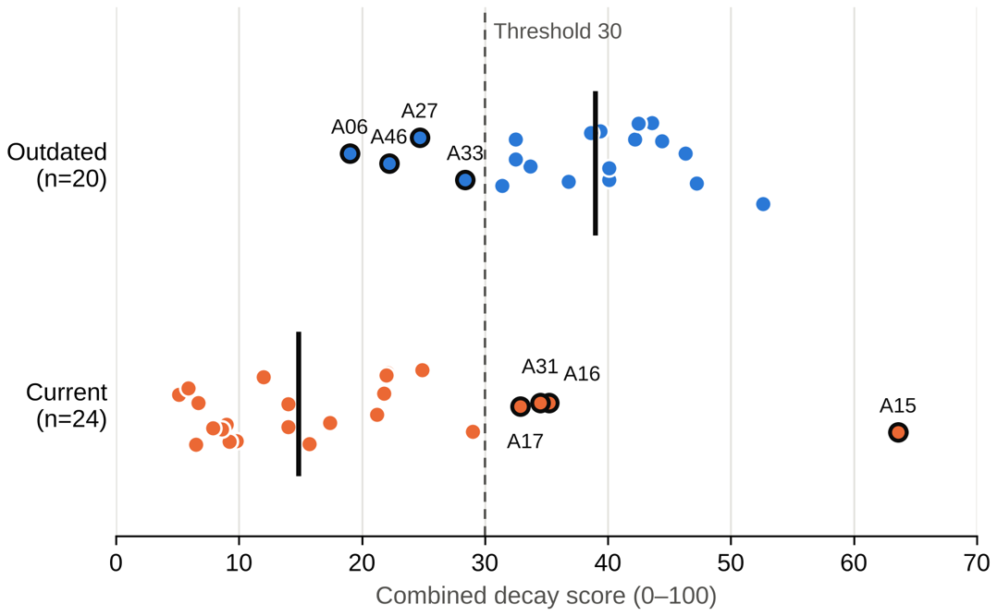

Figure 6.3:Scores of the 44 articles by true label

6.4.3. F-measure, Precision and Recall
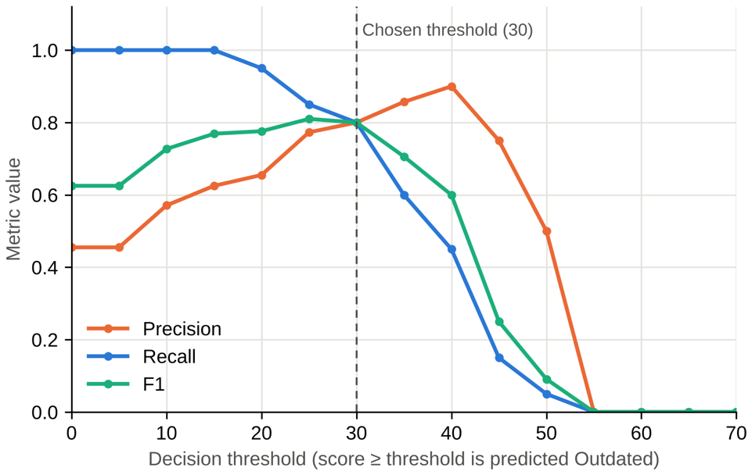
Precision, Recall and F1 are usual evaluation metrics used to evaluate the performance of detectors where there are only two classes. Table 6.2 gives the precision, recall and f1 scores at a threshold of 30. The confidence intervals provided in Table 6.2 were calculated using the wilson method for proportions (Wilson, 1927) and the Bootstrap for both F1 and AUC (Efron and Tibshirani, 1993) as these do not rely upon an assumption of normality; the latter being unsafe when dealing with 44 articles. Also, Figure 6.4 shows how they change with the threshold. A lower threshold finds more outdated articles but raises more false alarms, and a higher one does the reverse. The best F1 is 0.81 at a threshold of 25, but this is only 0.01 above the value at 30, and it was found on the same data it is measured on, so it is optimistic. The threshold was therefore kept at 30. Chapters 2 and 5 said that the threshold would be calibrated on the evaluation data. This was not done, because tuning and testing on the same 44 articles gives a result that is too optimistic, and 44 is too few to split. The sweep, which used steps of 5, is reported to show how sensitive the result is. A separate set of articles would be needed to tune the threshold fairly. The sweep also shows that no Outdated article scored above about 53, so the red band (above 60) was never reached by a correct case. The only article above 60 was a false alarm.

Figure 6.4:Precision, recall and F1 at different thresholds
Chapter 3 states the expectation that combining signals should do better than any single signal. Figure 6.5 tests this by leaving out one signal at a time and by using each signal alone. The terminology signal does most of the work. Without it, F1 falls from 0.80 to 0.25. On its own it reaches F1 0.79 and AUC 0.85. Leaving out any other signal changes F1 by no more than 0.04, and leaving out temporal even raises it to 0.84. The combined score ranks the articles slightly better than any single signal (AUC 0.887 against 0.852 for terminology alone), but at the threshold of 30 it does no better than terminology alone (F1 0.80 against 0.79). A bootstrap comparison shows that neither difference is reliable. The AUC difference is +0.04 with a 95% interval of −0.05 to +0.12, and the F1 difference is +0.01 with an interval of −0.12 to +0.13. The expectation is therefore only partly supported, and a larger dataset would be needed to settle it.
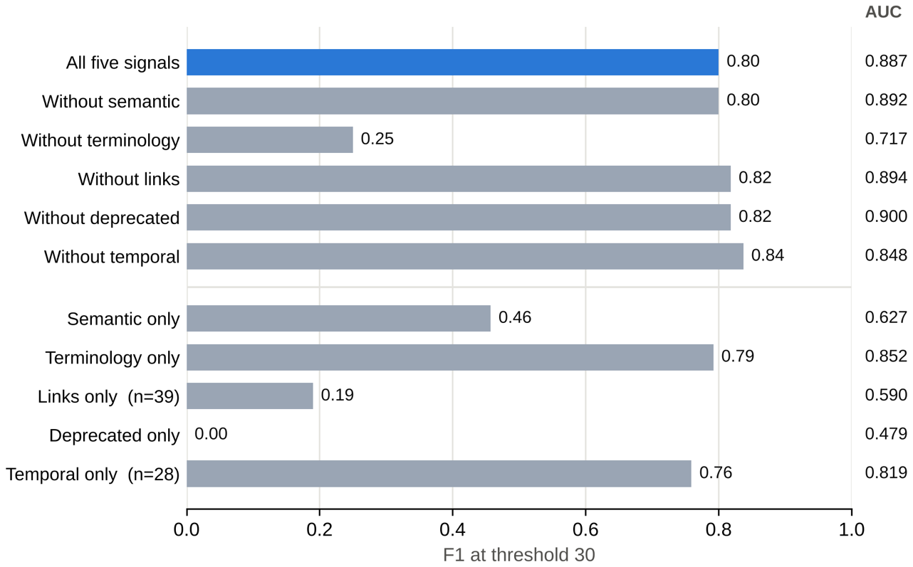

Figure 6.5:F1 and AUC when a signal is left out or used alone

Objective 4 of this study also asks for a comparison with traditional detection methods. The traditional method for judging staleness is the date of the page (Chapters 1 and 2), which is the temporal signal used alone. It can be used only on the 28 articles that have a date (14 Outdated and 14 Current), so the comparison was made on those 28. At the same threshold of 30, the combined score gave F1 0.79 and AUC 0.90, and the date alone gave F1 0.76 and AUC 0.82. The combined score is ahead, but the differences are not reliable with so few articles. The AUC difference is +0.08 with a 95% interval of −0.06 to +0.22, and the F1 difference is +0.03 with an interval of −0.13 to +0.19.
The other signals could not show their value on this sample. The temporal signal was usable for only 28 of the 44 articles. The deprecated technology signal fired once, on a Current article, so it contributed no correct detection. The semantic signal separates the groups poorly, because the mean decay is almost the same for Outdated (0.31) and Current (0.29) articles. Five of the eight lowest similarity values belong to articles on hybrid join and Autopilot (A38, A36, A37), Azure security best practice (A32) and Application Proxy (A22). The Entra corpus may cover such topics only in part, but this was not tested.
Chapter 5 left one question for this chapter. The terminology check does not count an old name when its sentence explains the change, and this might excuse sentences that should count. In 11 articles at least one mention was exempted. Table 6.7 shows what would have happened without the exemption. In the three Outdated articles with exemptions, terminology was already at its maximum, so the exemption did not cause a missed detection. In two Current articles (A48 and A43) the exemption kept the score below 30. Without it, there would be six false alarms instead of four, and F1 would fall from 0.80 to 0.76. This holds if the exempted sentences really were explanations of the rename. That was checked by hand for the InventiveHQ article in Chapter 5, but not for these 11 articles.
Table 6.7:Effect of the terminology exemption on the two articles that would change answer
Article | True label | Counted mentions | Exempted mentions | Score with exemption | Score without
A48 | Current | 3 | 6 | 21.2 | 31.2
A43 | Current | 3 | 2 | 22.0 | 32.0

6.4.4. ROC Curve
Figure 6.6 shows the ROC curve (Fawcett, 2006), which plots the share of Outdated articles found against the share of Current articles wrongly flagged, for every possible threshold. The area under the curve (AUC) is 0.887, with a 95% interval of 0.77 to 0.98. The lower end of the interval is well above 0.5, so the prototype ranks articles better than chance even in the unfavourable case. The point for the threshold of 30 lies close to the upper left corner. The results were also split by input route. The 34 web addresses alone give F1 0.77 and AUC 0.90, and the 10 pasted texts give F1 0.89 and AUC 0.83. The two groups agree well enough that pasting the text did not change the picture, although 10 articles are too few to compare closely.

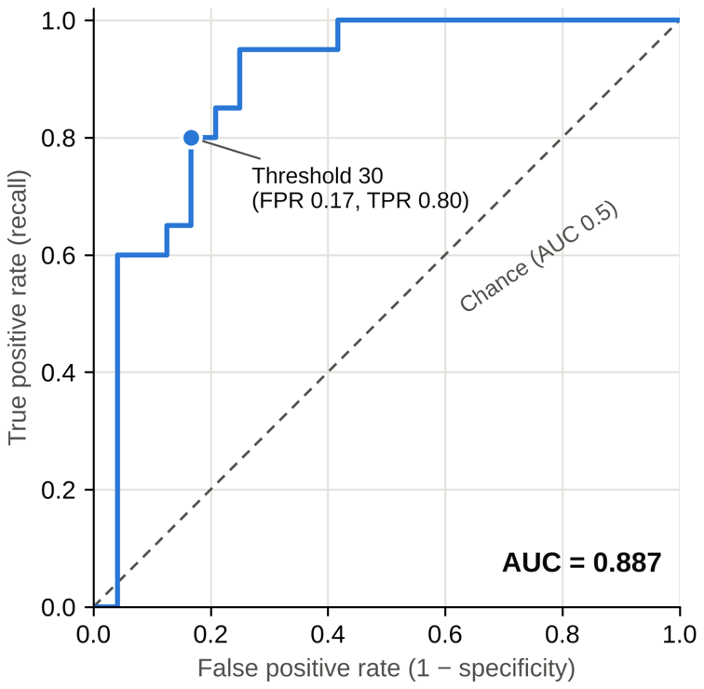

Figure 6.6:ROC curve of the combined score

6.4.5. Delphi Technique
The Delphi technique (Linstone and Turoff, 1975) collects the opinions of a panel of experts over several rounds. Chapter 3 allowed expert opinion in a narrow form, as an optional second review of a sample of labels. That review was not carried out, so every label is the judgement of one person. This is listed as a limitation in Chapter 7. A second rater would also allow Cohen’s kappa (Cohen, 1960) to be reported, and the batch script already supports it.

6.4.6. Iterative Framework
An iterative evaluation would improve the prototype in repeated cycles, each judged on the same measures. The prototype was built in stages (Table 5.1), but the labelled data was used only once, for the evaluation in this chapter. The threshold and the weights were not adjusted on it, because that would have made the results too optimistic. One change to the prototype was made before the batch run, and it did not use the labels: a link timeout is now treated as inconclusive and not as broken (Section 5.3.3).

6.4.7. Thematic Assessment
The eight wrong answers were read and grouped by cause, which follows the steps of thematic analysis (Braun and Clarke, 2006) on a small scale. Table 6.8 gives the result. The causes of the four false alarms were checked by reading the articles. The causes of the four missed articles come from their signal values, and the pages themselves were not re-read, so they are the likely causes and not confirmed ones. Three themes appear. The first is that old names appear because the article is about the retirement (A15, A16, A17). The prototype cannot yet tell talking about an old name from using it as the current name. The second is the grey area of A31, an older article whose concept and steps are still correct but which says Azure AD once and Azure Active Directory twice. It was labelled Current for its content, but the prototype was reasonable to flag the wording, so the dataset and the prototype disagree on what outdated means. The third is that very little text or a recent date weakens the score. Two missed articles gave under 2,000 characters, and a recent date gave A27 no temporal decay although it repeats old names 12 times.
Table 6.8:The eight wrong answers and their likely causes
ID | True label | Score | Signal pattern | Likely cause
A15 | Current | 63.6 | Terminology 1.0, deprecated 0.67; the date and links were not available | Checked: about retired or deprecated PowerShell modules, so old names are the topic
A16 | Current | 35.2 | Terminology 1.0 (15 mentions) | Checked: about retired or deprecated PowerShell modules
A17 | Current | 32.9 | Terminology 1.0 (10 mentions) | Checked: about retired or deprecated PowerShell modules
A31 | Current | 34.5 | Terminology 0.6, temporal 0.78 (40 months) | Checked: old article that still uses Azure AD names, but its content is correct
A06 | Outdated | 19.0 | Only 510 characters extracted; semantic 0.45, terminology 0 | Likely: too little text to judge (limit is 500)
A46 | Outdated | 22.2 | 1,967 characters; terminology 0.6; no date | Likely: short page and no date
A27 | Outdated | 24.7 | Terminology 1.0 (12 mentions); date only 2 months old | Likely: a recent date hides old wording
A33 | Outdated | 28.4 | Terminology 1.0 (25 mentions); the other signals low | Likely: near miss at the threshold

6.5. Chapter Summary
This chapter tested the prototype against its requirements and evaluated it on 44 labelled real articles. In the functional tests, the prototype met the requirements it was tested against, with two exceptions: the deprecated technology signal could not be evaluated, and the extractor read 34 of the 44 pages. Failed extractions returned a clear error and not a wrong score. On accuracy, the combined score found 16 of 20 outdated articles and wrongly flagged 4 of 24 current ones (precision 0.80, recall 0.80, F1 0.80, AUC 0.887). The chi-square, t-test and rank test all show that the scores separate the two groups far beyond chance. In speed, the median article took about 6 seconds (7 seconds for web addresses), and the time was linked mainly to the number of links.
The evidence is weaker than these figures may suggest, for five reasons. The dataset is small and search-based, and one person labelled it. More than half of the Outdated labels are old product names, which the terminology signal is built to find. The terminology signal alone does almost as well as all five signals together, and a bootstrap comparison cannot tell them apart. The red band was never reached by a correct case. There was no separate test set, and the threshold and weights are still provisional. Chapter 7 discusses these limitations and how they would be addressed with a larger data set and a second rater.

Concluding Remarks

7.1 Chapter Overview
This chapter draws the study together. Section 7.1 checks the four research objectives against the evidence from Chapters 5 and 6 and answers the research question. Section 7.2 describes the problems met and the limits of the study. Section 7.3 is a personal reflection with the contributions of the work. Section 7.4 looks at uses and commercial risks, and Section 7.5 gives recommendations for future work.

7.2 Accomplishment of the Research Objectives
The research question asked how a multi-signal AI framework can detect knowledge decay in enterprise knowledge bases through authoritative source comparison. A prototype was developed to score a third-party article on five signals against Microsoft documentation and this was then tested with 44 labeled third party articles. Each of the five research objectives are judged against that evidence as presented in Table 7.1.
Table 7.1:Evidence for each research objective
Objective | Evidence | Outcome
1. Identify the main indicators of decay | Five indicators were taken from the literature (Table 4.1). Terminology did most of the work: alone it gave F1 0.79 and AUC 0.85, and without it F1 fell from 0.80 to 0.25. The date alone gave F1 0.76 on the 28 dated articles. Semantic similarity and broken links were weak alone, and deprecated technology could not be judged. | Achieved in the literature. The data clearly support terminology and, where one exists, the date.
2. Analyse semantic and authoritative-source comparison | The glossary of vendor renames worked best. Similarity to the corpus separated the groups poorly: mean decay 0.31 for Outdated and 0.29 for Current articles, and an AUC of 0.63 alone. | Achieved in part. Similarity alone did not show whether an article was current.
3. Implement an explainable prototype | Five signal modules, a one-page interface and plain-language explanations (Chapter 5). Of ten main test cases, eight passed, one passed in part (34 of 44 pages could be read) and one could not be evaluated (deprecated technology). The median time was 6.3 seconds. The explanations were checked on four articles only. | Achieved, with gaps in page reading and in testing explanations and interface.
4. Compare the framework with traditional methods | Five test strategies (Chapter 6). The combined score had an AUC of 0.887 against 0.852 for the best single signal, and an F1 of 0.80 against 0.79. On the 28 dated articles its AUC was 0.90 against 0.82 for the date alone. No difference was reliable, because every interval included zero. | Achieved as an evaluation. A reliable advantage was not shown.

The accuracy result was checked in four ways (Table 7.2). The methods use the same 44 articles, so they are not fully independent, but they ask different questions. The first two agree that the scores separate the two groups. The last two show where the prototype is weaker.The answer to the research question is therefore a qualified one. A framework of five signals can separate outdated from current articles in this sample: it found 16 of 20 outdated articles and wrongly flagged 4 of 24 current ones. But most of that ability came from one signal, and the study could not show that combining the signals beats terminology alone. The expectation set in Chapter 3 is therefore only partly supported.
The accuracy result was checked in four ways (Table 7.2). The methods use the same 44 articles, so they are not fully independent, but they ask different questions. The first two agree that the scores separate the two groups. The last two show where the prototype is weaker.
Table 7.2:Triangulation of the accuracy result
Method | Question asked | Finding | Supports the result?
Chi-square, Welch t-test and rank test | Are answers linked to labels, and do Outdated articles score higher? | χ²(1) = 17.65, p < 0.001; means 36.9 and 18.7, p < 0.001, Cohen’s d = 1.57 | Yes
Precision, recall, F1 and ROC curve | How many answers are right, at one threshold and at all? | Precision 0.80, recall 0.80, F1 0.80; AUC 0.887 (0.77 to 0.98) | Yes, with wide intervals
Ablation and baselines | Is the combination better than one signal or the date? | Terminology alone is almost as good; no reliable gain | Only in part
Thematic assessment of the eight wrong answers | Why were answers wrong? | Retirement articles (A15, A16, A17), a grey-area article (A31), and short or recent pages (A06, A46, A27) | Shows the limits

7.3 Problems Encountered

7.3.1 Problems During the Project
Chapter 5 recorded the technical problems found during development (Table 5.12), and each was solved before the evaluation. Three further problems arose later and affected the results.
Reading web pages. Ten of the 44 addresses returned no readable text, so extraction worked for 77% of the pages and the text of the other 10 had to be pasted by hand. Many of these pages held a lot of screenshots, but this was not tested as the cause.
Time. The project timeline (Table 3.2) placed dataset collection and labelling in August and September. In practice the articles were collected and labelled in mid-October, so the evaluation, the analysis and much of the writing fell in the last weeks. The risk of limited development experience in Table 3.4 also became real, and the modular design and the supervision meetings reduced the damage, as intended.
The dataset. Table 3.4 planned to add synthetic decay cases to a small dataset. None were added, so the evaluation rests on 44 real articles.

7.3.2 Limitations of the Study
Table 7.3 lists the limits of the study and what each one means for the conclusions.
Table 7.3:Limitations of the study and their effect on the conclusions
Limitation | Effect on the conclusions
A small, search-based sample of 44 articles on one product family | Results describe this sample only. The accuracy interval is wide (0.68 to 0.90).
One rater, so no kappa. 17 labels have Medium and 1 has Low confidence | Some labels may be disputed (for example A31).
12 of the 20 Outdated labels are due to old terminology | This overlaps with what the terminology signal looks for, so its result is partly built into the sample.
Threshold of 30 and equal weights are provisional, with no separate test set | Values are untuned, and better settings are unknown. No correct case reached the red band (above 60).
Deprecated technology could not be judged (one labelled example). The date was usable for 28 articles | The value of these two signals is not proven.
Only text is read, and 10 pages needed pasting | Screenshots and video are not assessed. Extraction covered 77% of pages.
One authority (Microsoft Learn), one product area, English only, and hand-made lists (5 name pairs, 4 technologies) | The findings may not hold for other vendors or topics.
There is no version-drift signal | An article for an older product version that uses current names is not caught.
Interface and explanations not tested with users | NFR2 is unproven, and FR10 and NFR3 were checked on four articles only.

7.4 Self-Reflection

7.4.1 My View of the Research
As an IT Professional working with Microsoft 365 and Entra ID, I started this work because I believed the Pragmatist approach (as described in Chapter 3) where methods should be kept if they prove useful on actual case studies, thus I wanted it tested using real world cases rather than artificial ones.
My findings have completely altered how I viewed this issue. As the original study title clearly stated, comparing a prototype to an Authoritative Source is central to this study; and the semantic signal is that part of the prototype which allows direct comparison to that source. From these data, I took away two main points. One: A simple, low-cost and easily understood validation/evaluation can often outperform an intelligent solution. And Two: Scores are best used to guide a user to examine, rather than serve as final judgment. Article A31 has correct steps, however uses outdated terminology; showing that users may disagree regarding what is 'outdated'.

7.4.2 Benefits Gained and Contributions
Benefits gained. I had roughly fifteen years of infrastructure experience but was completely without a coding background. I learned how to create a functional pipeline using Python, how to apply sentence embeddings & a vector search index, how to set up an evaluation method, and utilize statistical techniques (including bootstraps for interval estimation and rank tests) that were unfamiliar to me.
Contributions. There are two types of contributions made to the field of research. First there are conceptual. This study presents a combination of five different signals (link integrity, semantic similarity, terminology drift, date and depreciated technology), in an single analytical model using both vendor's own documentation and third party authored content. In addition, it treats missing or unreliable data as "not applicable" or "inconclusive", therefore if a web site is blocked or a date cannot be found, it will be considered as decay but will have less weight than the other sources of decay. To my knowledge, as described in the literature survey of Chapter 2, no prior studies have used combinations of similar signals for third party authored technical content.
Secondly, they represent practical and empirical. The study provides a functioning explanatory prototype; a labeled dataset of 44 articles, along with reasons provided for each label, comments about why the label was assigned and confidence levels for those labels; and evidence demonstrating what signal matters, including a detailed analysis of the terminology exception, and the eight incorrect answers. Due to the limitations presented in Section 7.3.2, the evidence has been somewhat limited. Therefore, these contributions should be viewed as a first design that has been tested and validated, rather than as an absolute complete methodology.

7.4.3 Learning Curves
The most difficult curve was programming. I worked on one piece of the program at a time and tested every script by hand. My supervisor stated it would be okay to use an AI tool to help me write the code, and also for organizing. Three episodes were especially useful in teaching me lessons. The first lesson was that testing can fail like code can. When the link-checker test failed on my Windows machine, it wasn't due to the link-checker itself, but rather from the timing of the tests, along with their test servers. This is something I learned only after viewing why each test had failed. The second lesson was that sometimes just a single detail in your data can cause all downstream processes to fail. A hidden byte order mark was placed at the end of a results file, and thus caused my analysis script to fail. Lastly, I set my labels prior to looking at any results and didn't make changes to those labels regardless of how mixed the results appeared, because you can only trust the results of your evaluation if you know they weren't based upon your labels.
In Kanban (Section 3.7), I maintained small steps for the build process; however, I should have organized and labeled the dataset prior to starting the evaluation process, since the outcome of the evaluation determined everything else.

7.5 Business Insight of the Idea
The business case rests on a cost that Chapter 1 described: wasted effort and rework when out-of-date information is not recognised. The prototype does not remove that cost. It points a person to the articles that most need a second look, and it gives reasons.

7.5.1 Real-World Application Possibilities
At the point of use. A browser add-on might display a decay score adjacent to an article as an engineer reviews it. This is the first of the two deployment paths defined in Section 1.10. It only requires the single-article scoring already done by the prototype.
Knowledge base audits. Runbooks for managed service providers and internal IT teams reference vendor product names. A scheduled scan can sort those pages by decay score so reviewers start with the most likely to be out of date pages. This is the 2nd path from Section 1.10 Monitoring.
A quality gate for AI assistants. It has been shown that retrieval based assistants’ re-rankers will favor older semantically richer documents even if the content is obsolete (An et al., 2026). A decay score could filter such passages or rank them down before writing an answer.

7.5.2 Commercial Risks and Their Treatment
Any commercial use would face the risks in Table 7.4. The first comes directly from the results of this study.
Table 7.4:Main commercial risks and how they could be reduced
Risk | Why it matters | Possible treatment
Wrong answers | At the threshold of 30 the prototype missed 4 of 20 outdated articles and flagged 4 of 24 current ones. Misses give false comfort and false alarms waste time. | Show reasons, mark signals not assessed, and keep a person in the decision.
Dependence on one vendor source | The authority is the Microsoft Learn repository. A change in its structure, content or licence would affect every score. | Keep a dated snapshot, check licence terms before commercial use, and refresh regularly.
Upkeep of the hand-made lists | The glossary has five pairs and the technology list four entries. Each new rename needs an update, which is a running cost. | Build the lists from vendor release notes and review them on a schedule.
Access to third-party content | Ten of 44 pages could not be read, and some sites block programs. Copying and storing articles may break site terms or copyright. | Offer pasted text, store nothing (FR11) and respect site terms.

7.6 Future Recommendations
The recommendations follow from the limits in Section 7.3.2, in the order in which they would be done.
A stronger evaluation. Collect several hundred articles, including other products, and keep part as a test set that is never used to choose settings. Add a second rater so that Cohen’s kappa can be reported, add the synthetic decay cases that Chapter 3 planned, test the deprecated technology signal with articles chosen for it, and use the larger dataset to set the weights and band limits.
Better signals. Add a version-drift signal. Build the glossary from vendor rename notices and not by hand. Teach the terminology check to tell an article about a retired name from one that uses it as current, which caused three of the four false alarms (A15, A16 and A17). Replace plain similarity with a check that compares statements and looks for contradictions. Test whether screenshots caused the failed page reads and, if so, read the text in images.
Engineering. Add automated tests, which the prototype lacks, and move to an approximate nearest-neighbour index if the corpus grows far beyond 123,193 chunks (Section 6.2.1.3).
Deployment and scope. Build the browser extension and the scheduled scan of Section 7.5.1, extend the corpus to other vendors and languages, and compare the framework with a large language model used as a judge.
In summary, this study showed that a small set of explainable checks can separate many outdated third-party articles from current ones, and that old product names are the strongest sign. It did not show that combining all five signals beats the best single one. A larger, better-labelled dataset is the most important next step.

References

Alexander, I.F. and Beus-Dukic, L. (2009) Discovering Requirements: How to Specify Products and Services. Chichester: Wiley.
An, S., Lee, H., Yuan, S., Chen, C.J., Hsieh, C.J., Mohan, V. and Min, A. (2026) FRESCO: Benchmarking and Optimizing Re-rankers for Evolving Semantic Conflict in Retrieval-Augmented Generation. arXiv preprint arXiv:2604.14227.
Anderson, D.J. (2010) Kanban: Successful Evolutionary Change for Your Technology Business. Sequim, WA: Blue Hole Press.
Bloomfire (2026) What Knowledge Management Software Really Costs. Available at: https://bloomfire.com/blog/poor-knowledge-management-software/ (Accessed: 31 July 2026).
Gao, Y., Xiong, Y., Gao, X., Jia, K., Pan, J., Bi, Y., Dai, Y., Sun, J. and Wang, H. (2023) Retrieval-Augmented Generation for Large Language Models: A Survey. arXiv preprint arXiv:2312.10997.
Hevner, A.R., March, S.T., Park, J. and Ram, S. (2004) 'Design science in information systems research', MIS Quarterly, 28(1), pp. 75–105.
Jeong, S., Baek, J., Cho, S., Hwang, S.J. and Park, J. (2024) Adaptive-RAG: Learning to Adapt Retrieval-Augmented Large Language Models through Question Complexity. Proceedings of NAACL 2024, pp. 7036-7050.
Johnson, J., Douze, M. and Jegou, H. (2019) 'Billion-scale similarity search with GPUs', IEEE Transactions on Big Data, 7(3), pp. 535-547.
Karpukhin, V., Oguz, B., Min, S., Lewis, P., Wu, L., Edunov, S., Chen, D. and Yih, W. (2020) 'Dense Passage Retrieval for Open-Domain Question Answering', Proceedings of EMNLP 2020, pp. 6769-6781.
Lewis, P., Perez, E., Piktus, A., Petroni, F., Karpukhin, V., Goyal, N., Kuttler, H., Lewis, M., Yih, W., Rocktaschel, T., Riedel, S. and Kiela, D. (2020) 'Retrieval-Augmented Generation for Knowledge-Intensive NLP Tasks', Advances in Neural Information Processing Systems (NeurIPS), 33.
Luu, K., Khashabi, D., Gururangan, S., Mandyam, K. and Smith, N.A. (2022) 'Time waits for no one! Analysis and challenges of temporal misalignment', Proceedings of NAACL 2022, pp. 5944-5958.
Microsoft (2025) Microsoft Learn Documentation. Available at: https://learn.microsoft.com/ (Accessed: 31 July 2026).
Oates, B.J. (2006) Researching Information Systems and Computing. London: Sage Publications.
Peffers, K., Tuunanen, T., Rothenberger, M.A. and Chatterjee, S. (2007) 'A Design Science Research Methodology for Information Systems Research', Journal of Management Information Systems, 24(3), pp. 45–77.
ProcedureFlow (2026) The Hidden Cost of Stale Knowledge and What It Is Costing Your Organization. Available at: https://blog.procedureflow.com/knowledge-management/the-hidden-cost-of-stale-knowledge-and-what-it-is-costing-your-organization (Accessed: 31 July 2026).
Reimers, N. and Gurevych, I. (2019) 'Sentence-BERT: Sentence Embeddings using Siamese BERT-Networks', Proceedings of EMNLP-IJCNLP 2019, pp. 3982-3992.
Richardson, L. (2025) Beautiful Soup Documentation. Available at: https://www.crummy.com/software/BeautifulSoup/bs4/doc/ (Accessed: 26 September 2026).
Saunders, M.N.K., Lewis, P. and Thornhill, A. (2019) Research Methods for Business Students. 8th edn. Harlow: Pearson.
Schwaber, K. and Sutherland, J. (2020) The Scrum Guide: The Definitive Guide to Scrum: The Rules of the Game. Scrum.org and Scrum Inc.
Sommerville, I. (2016) Software Engineering. 10th edn. Boston: Pearson.
Streamlit Inc. (2026) Streamlit Documentation. Available at: https://docs.streamlit.io/ (Accessed: 26 September 2026).
Tran, T. and Cao, T.H. (2013) 'Automatic Detection of Outdated Information in Wikipedia Infoboxes', Research in Computing Science, 70, pp. 211-222.
Tu, H., Yu, S., Saikrishna, V., Xia, F. and Verspoor, K. (2024) Deep Outdated Fact Detection in Knowledge Graphs. arXiv preprint arXiv:2402.03732.
Yu, S. et al. (2026) Knowledge Integration Decay in Search-Augmented Reasoning of Large Language Models. arXiv preprint arXiv:2602.09517.
Zhang, H., Wang, S., Chen, T.H., Zou, Y. and Hassan, A.E. (2021) 'An Empirical Study of Obsolete Answers on Stack Overflow', IEEE Transactions on Software Engineering, 47(4), pp. 850-862.
Zoho (2023) Hidden Costs of Poor Knowledge Management. Available at: https://www.zoho.com/learn/focalpoint/hidden-costs-of-poor-knowledge-management.html (Accessed: 31 July 2026).

